**Final Portfolio**

Trey McAtee

CPE 272

12/7/2020

**Table of Contents**

Page 3 - 4: Course Reflection

Page 4: Revision History

Page 5 - 103: Lab Reports

Page 5 - 17: Lab 1

Page 17 – 26: Lab 2

Page 26 – 36: Lab 3

Page 36 – 49: Lab 4

Page 49 – 59: Lab 5

Page 59 – 77: Lab 6

Page 77 – 87: Lab 7

Page 87 – 94: Lab 8

Page 94 – 99: Lab 9

Page 99 – 103: Lab 10

Page 104: Lab Notes

**Course Reflection**

I would like to preface this section by saying that I am a CS major with an area of emphasis in CSE and a minor in philosophy. During the semester, one of the lessons that I have deemed to be the most important is the importance of modular design. It is a truly efficient way of doing things and has been reinforced by other classes I have taken this semester as well. To have separate portions of code that you have tested and know work well instead of a monolith of code is simply more efficient. It is easier on the eyes, easier to understand, and frankly easier to test. This lab section has not only been the first to introduce just how important modular design can be but also reinforces the notion that modular-based coding and circuit design is probably the most effective path to creating unique and more complicated designs. Also, I did not work with a partner throughout the entire semester, but I have worked with teammates on CS projects before. To have a monolith of code that you need to break down for the other person is just a massive challenge by itself. You need to make sure every little detail is understood by the other person for them to be able to assist in the project. However, with modular design that becomes simply so much easier. People can work on different parts of one project and have it set up in a way that is both easier for everyone to understand and creates a more controlled environment for errors.

Secondly, the overall concept of digital logic was introduced to me in this lab in a way that is much easier to understand then I was previously. I have taken the CS 220 (discrete mathematics) course at WVU previously. However, it was during the spring 2020 semester, or the semester that all classes went online due to COVID-19. I was certainly struggling in that course, and likely passed due to perseverance alone. I was quite shaky on my knowledge of those concepts, ranging from simple truth tables to extremely large and more complicated ones. Being introduced again to these concepts as if I had not already taken that class was quite good, as I do not think I would understand them as well as I should without this course. Basically, being forced to go over the fundamentals of digital logic in this course also made me reinforce prior knowledge of previously just theoretical logic. I believe firmly that being able to test and play around with the digital logic of this course has helped me to better understand these concepts. My newly enhanced understanding of both this and the importance of modular design have, I believe, made me into a much better programmer who is capable of greater things. It has also enhanced my confidence in my own ability to program.

**Revision History**

I am content with the way that my lab reports are in their current state, I feel as though I did learn quite a bit in this course. Lab reports are the same as they are from when I originally turned them in, aside from lab 1 because there was an issue on Turnitin with my lab report only showing part 1. Some of the formatting such as spacing is not the exact same either, but the content of the reports are not changed. This issue was resolved via email already though earlier in the semester.

**Lab Reports**

**Introduction to Quartus Prime, DE10-Lite Board, & Basic Logic Gates**

Trey McAtee

CPE 272 Lab 1

9/6/2020

No Partners

**Introduction**

The first lab of CPE 272 is meant to allow the students to get familiar with the Quartus Prime software and to introduce them to the circuit board. It certainly feels as though the first lab is not designed to be difficult, serving as a great entry point for students who have never worked with a piece of equipment such as this before, as those with no experience may find it very intimidating. In part 1 of the lab, students will familiarize themselves with the way that truth tables work and understand the connection and relationship between truth tables and the provided hardware. In part 2, students will get comfortable with the quartus prime software and perform their first simple operations to the board, further utilizing truth tables to understand the possible inputs and outputs. In part 3, we had a similar process to that of part 2 except that we had to make our own logic diagram and program it from scratch.

**Part 1:**

**Experiment**

The experiment in part 1 was to take the below logic circuit diagram and correctly find its corresponding outputs given any scenario of inputs.

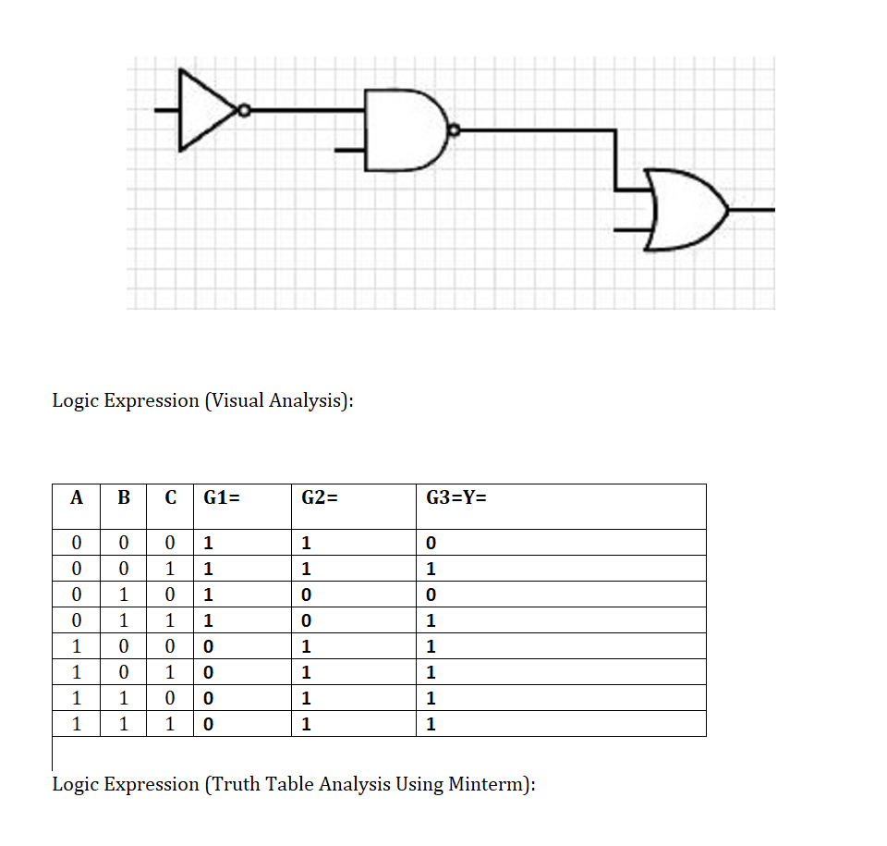

Figure 1, logic diagram and its respective truth table filled in with outputs.

**Results**

I started by separating the inputs into A, B, and C, then assigning input A to the NOT gate, B to the NAND gate, and C to the OR gate. The outputs for each gate have been listed in bold in the screenshot’s truth table.

**Part 2:**

**Experiment**

The experiment in part 2 focused on really familiarizing students to the Quartus Prime program via replicating a logic diagram (replication shown below) that was given in the lab handout. 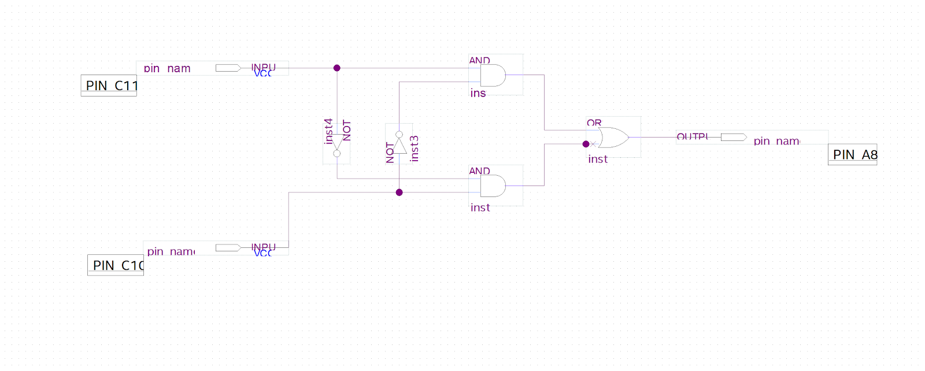

Figure 2, logic diagram replication in Quartus Prime Software.

Then, students were tasked with programming the board to work properly with Quartus Prime and to replicate the behavior of the logic diagram onto the physical board.

**Results**

I started by drawing out the logic diagram on paper and labeling the parts again. It seemed easier for me to think about the diagram, so I also drew out a corresponding truth table for the logic diagram. Once I understood the proper output values of the truth table, I then began to test my board to see if the outputs would match up. As you can see, I made a few mistakes in my table, but those were quickly corrected as I realized from testing the board that something wasn’t adding up. My on-paper diagrams are shown below, along with evidence of my board working properly with my student ID.

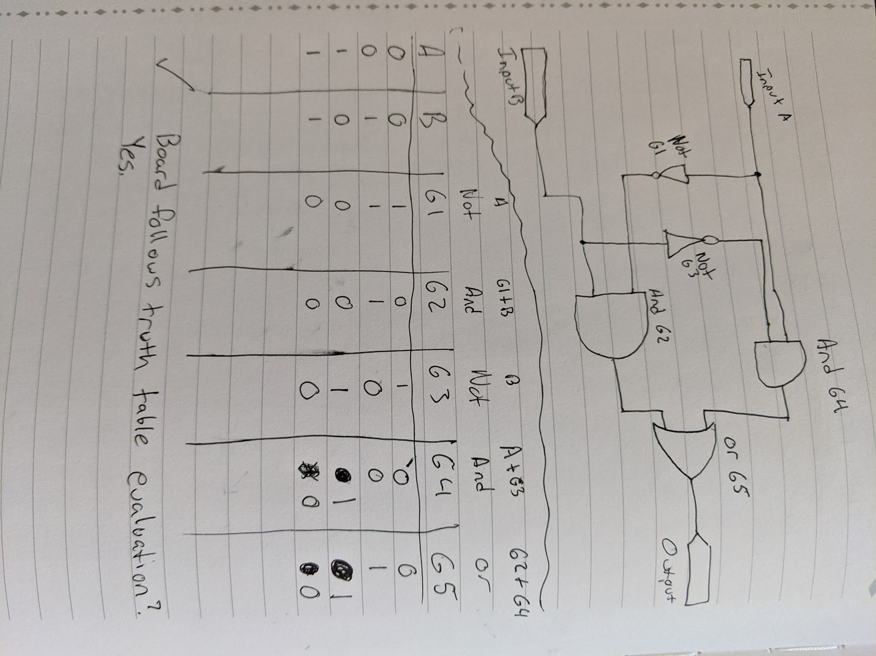

Figure 3, hand drawn logic diagram and truth table

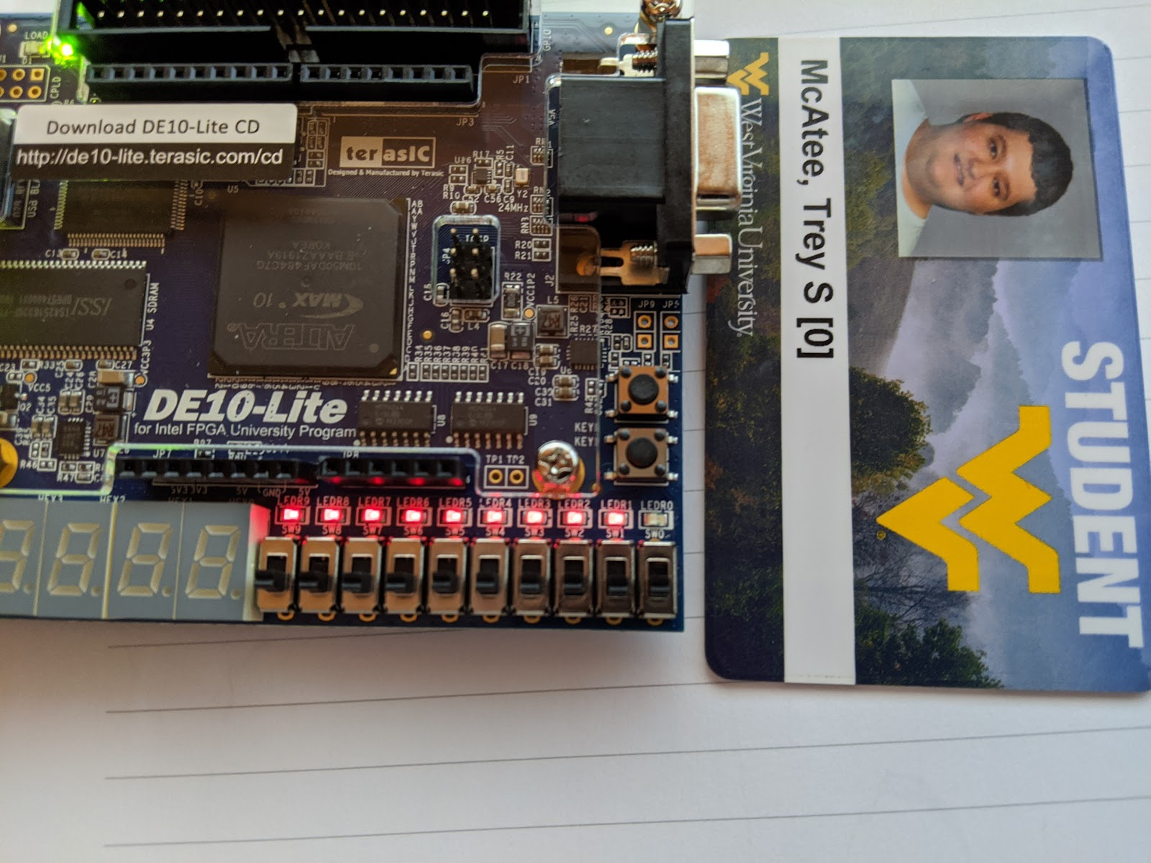Figure 4, board showing results of A and B input = 0 and result as 0.

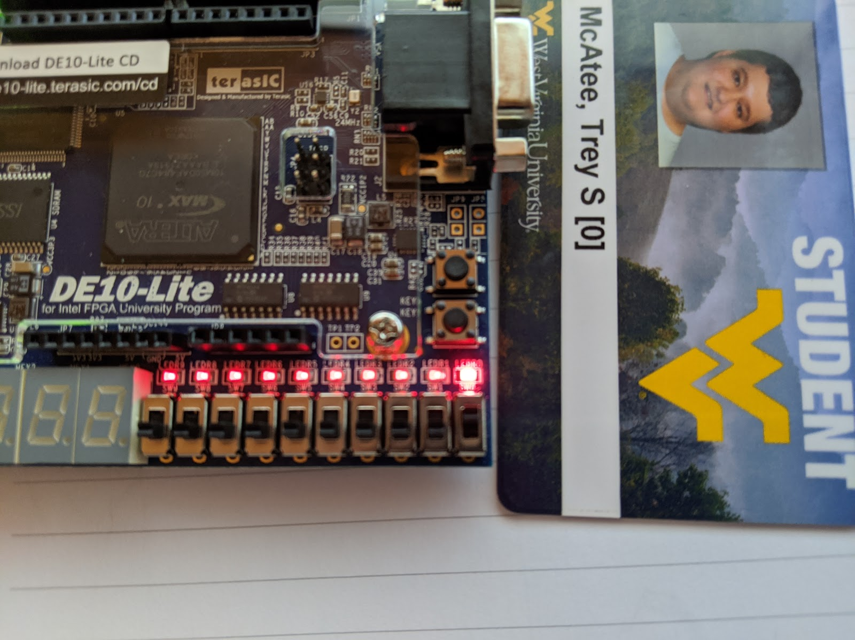Figure 5, board showing results of inputs A = 1 and B = 0 and result as 1.

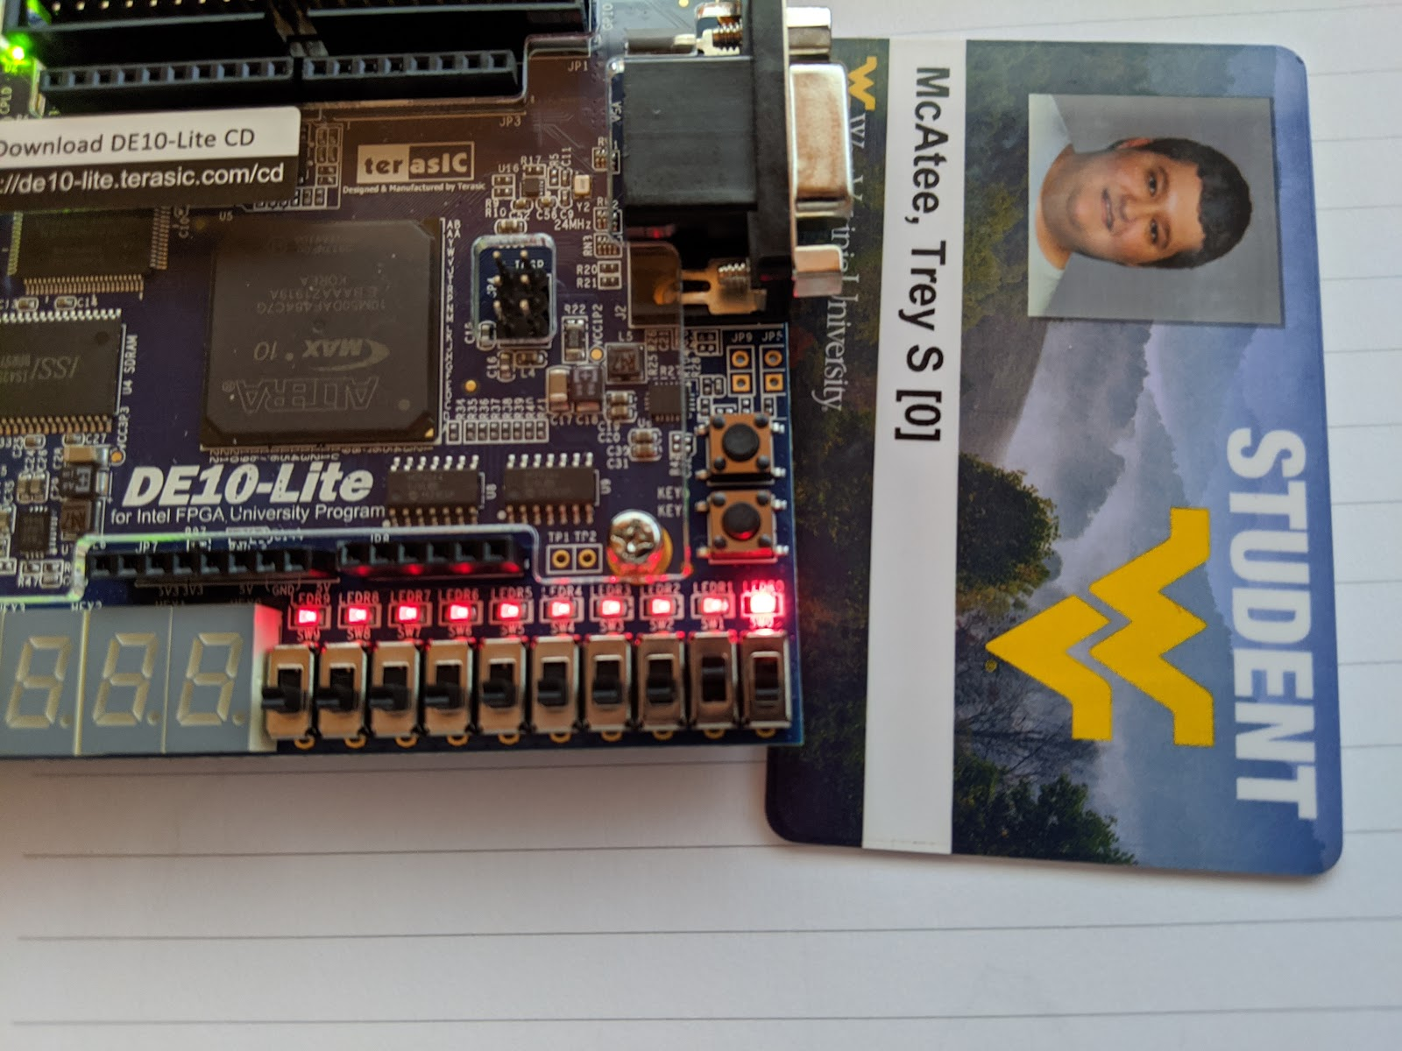Figure 6, board showing results of inputs A = 0 and B = 1 and result as 1.

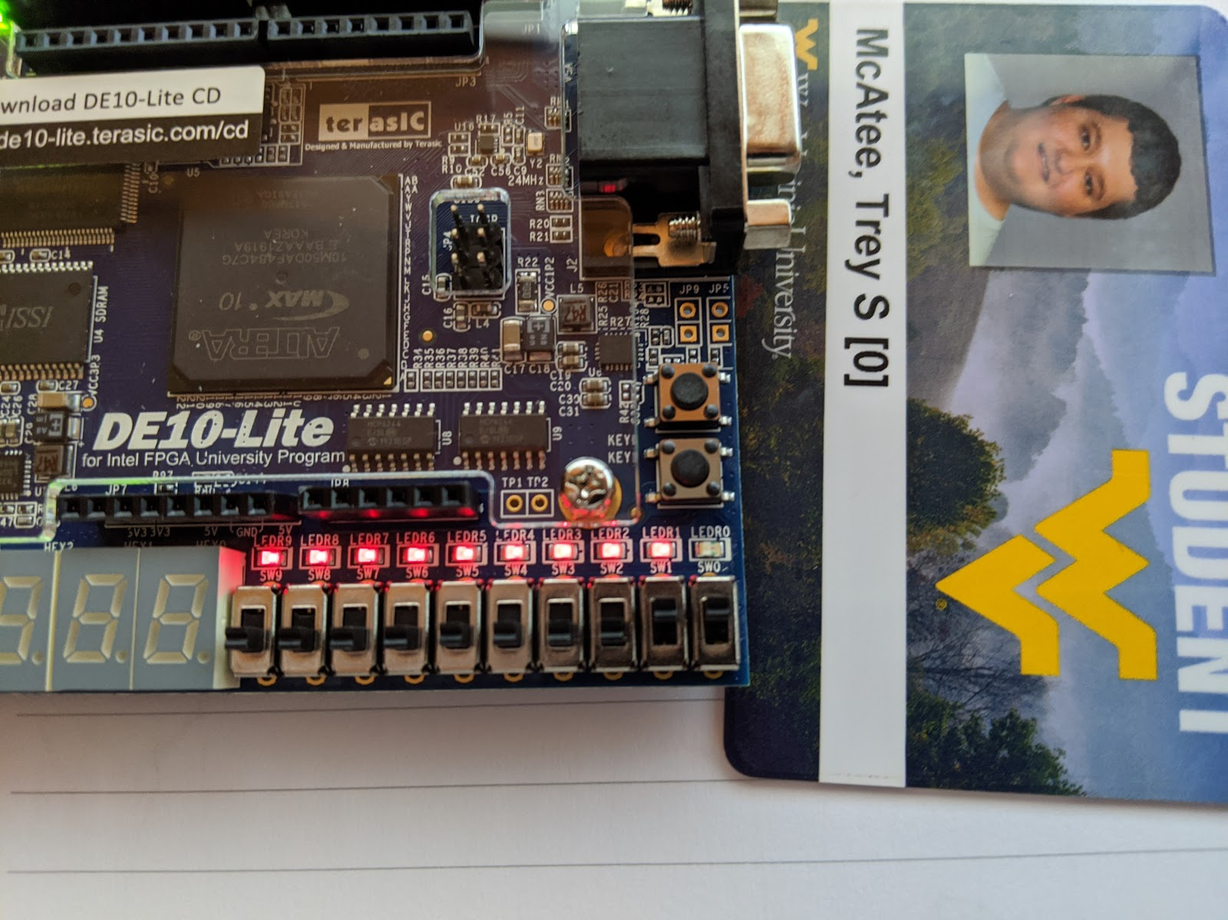

Figure 7, board showing results of inputs A = 1 and B = 1 and result as 0.

**Part 3:**

**Experiment**

For part 3, we had to take three inputs in binary from 0 to 7, and represent only the numbers divisible by 3, in other words, only on a 3 or a 6 was the output supposed to be positive.

**Results**

I had some trouble with this part. I was able to develop a logic diagram and put together a simple truth table to visualize the outputs, and even made a logic expression to represent the correct outputs. However, I was unable to program the board correctly with quartus to represent these results; every attempt would recreate the results as programmed from part 2. So, the handwritten process is shown below. 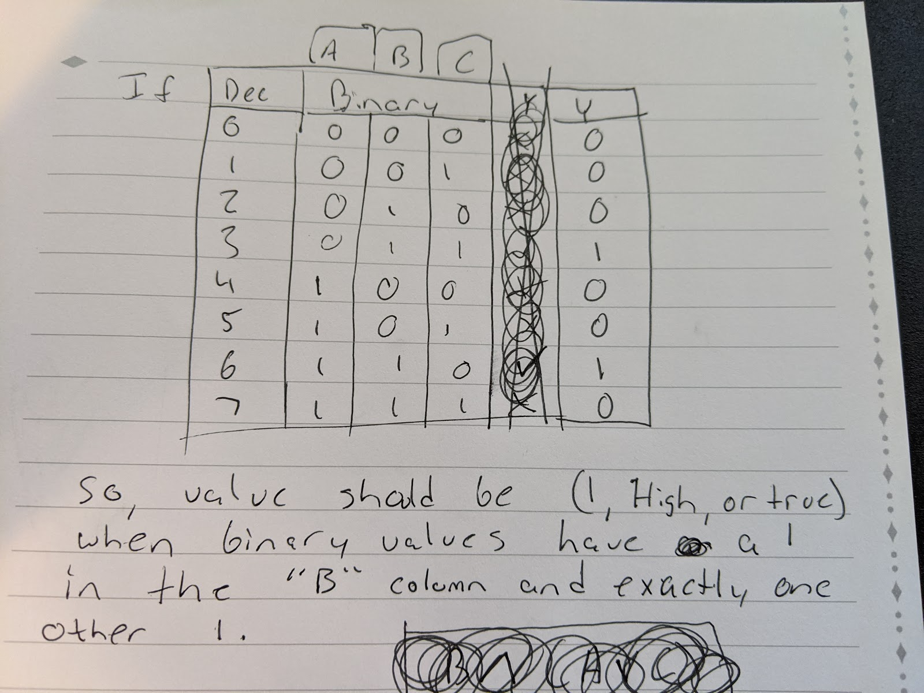

Figure 8, the truth table representation of part 3’s problem.

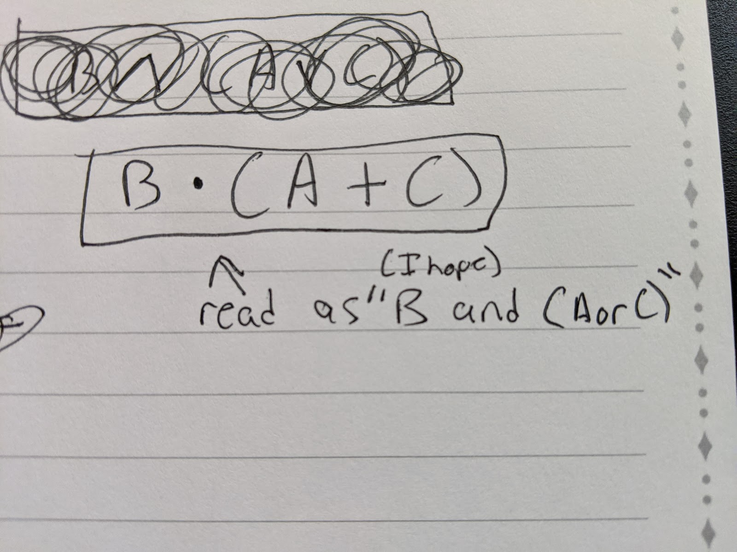

Figure 9, the logical expression of the problem that helped me create the diagram

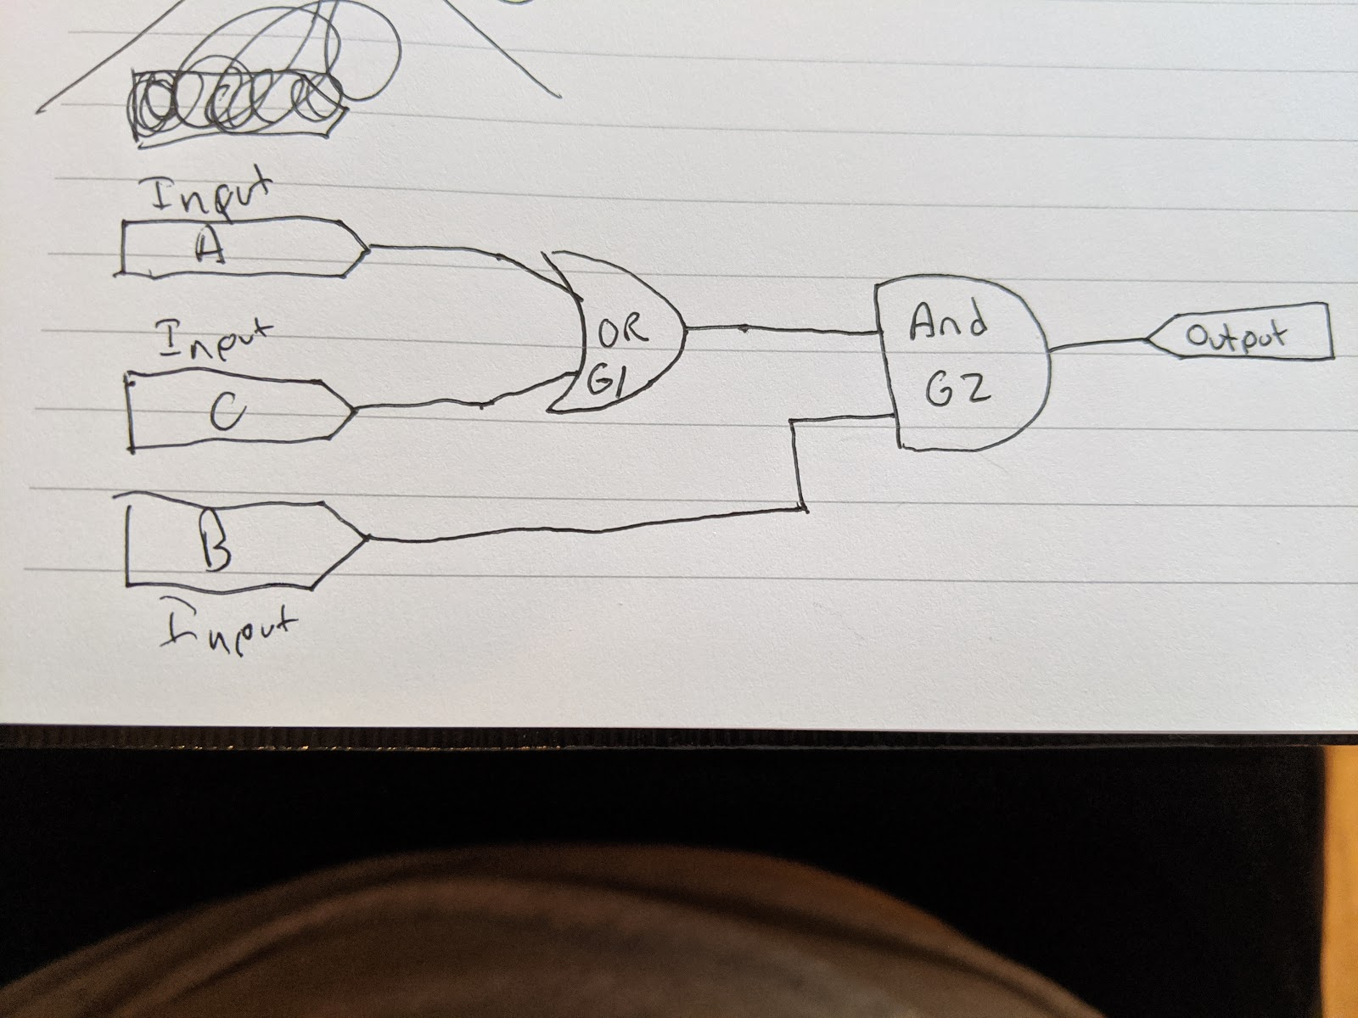

Figure 10, the actual logic diagram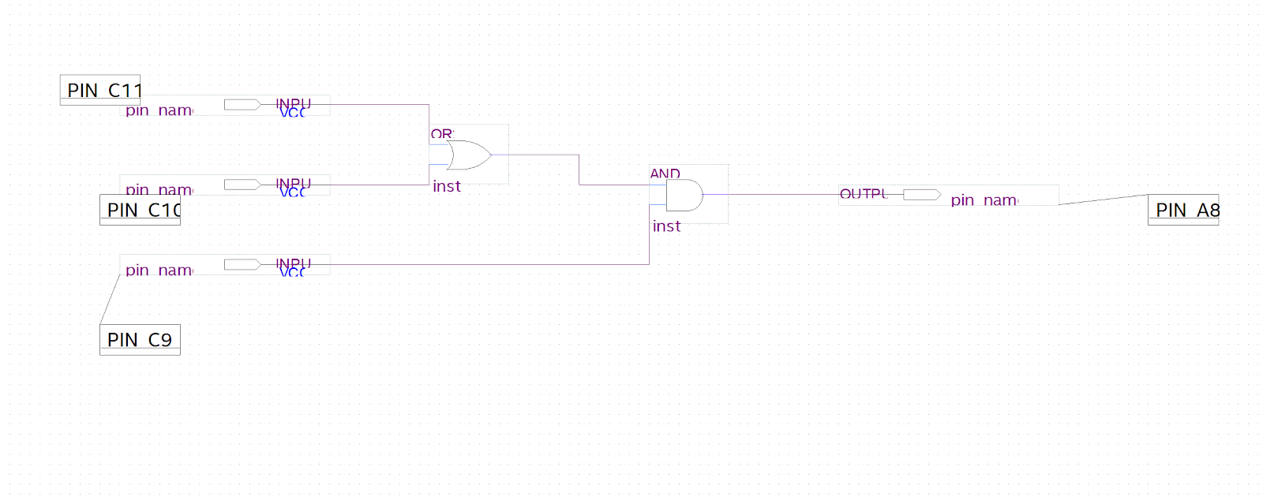

Figure 11, the logic diagram recreated in Quartus Prime

**Conclusions**

Even with my failure of part 3, I feel like I learned alot from this lab. Part 2 actually felt very satisfying when the board properly displayed my results, and although I had already learned about truth tables in a previous course, this lab provided a good refresher of how to evaluate them. It also provided excellent context with different logic gates, as said previous course dealt only with the technical side of things, and had no practical examples to attach them too. This lab surely has deepened my understanding of evaluating truth tables, and my previously nonexistent knowledge of logic gates and circuit boards.

POST LAB QUESTIONS

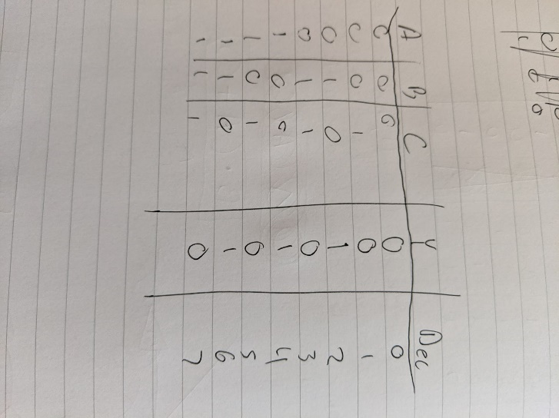 number 1

PRE LAB 2 QUESTIONS

1. A seven segment display is what is currently equipped to the boards given to the class for this lab. The numbers/letters that appear in each position are created using the seven segment display.

**PLD’s, FPGA’s & Seven-Segment Displays**

Trey McAtee

CPE 272 Lab 2

9/13/2020

No Partners

**Introduction**

The second lab of CPE 272 is meant to give students an understanding of the seven-segment display equipped onto the board, and how to properly work with it in the Quartus Prime software using the VHDL filetype. It shows the real bit values that the board interprets to display different numbers and letters. This is worth learning because we need to understand how to effectively use to board supplied to us, as if we did not then many other learning outcomes further in the course would be most likely completely missed.

**Part 1:**

**Experiment**

The experiment in part 1 was to fill out a truth table to find what inputs the board would need to have in order to output different characters. In the truth table, the input values (W, X, Y, and Z) are supplied as binary numbers to be converted into their respective hexadecimal values. Then, we should list the minterms of each equation to simplify coding them into the board for later.

**Results**

The filled-out truth table and minterm equations are posted below, as figures 1 and 2 respectively. The input values each supply one binary bit of data and depending on their combination each output value will either return a zero or a one. A zero-output value would mean that the section on the seven-segment display is supposed to light up, and a one would mean that the segment is supposed not supposed to light up. For example, if the “a” (or 0) section of the seven-segment display receives a zero value (logic low), then the “a” section will light up.

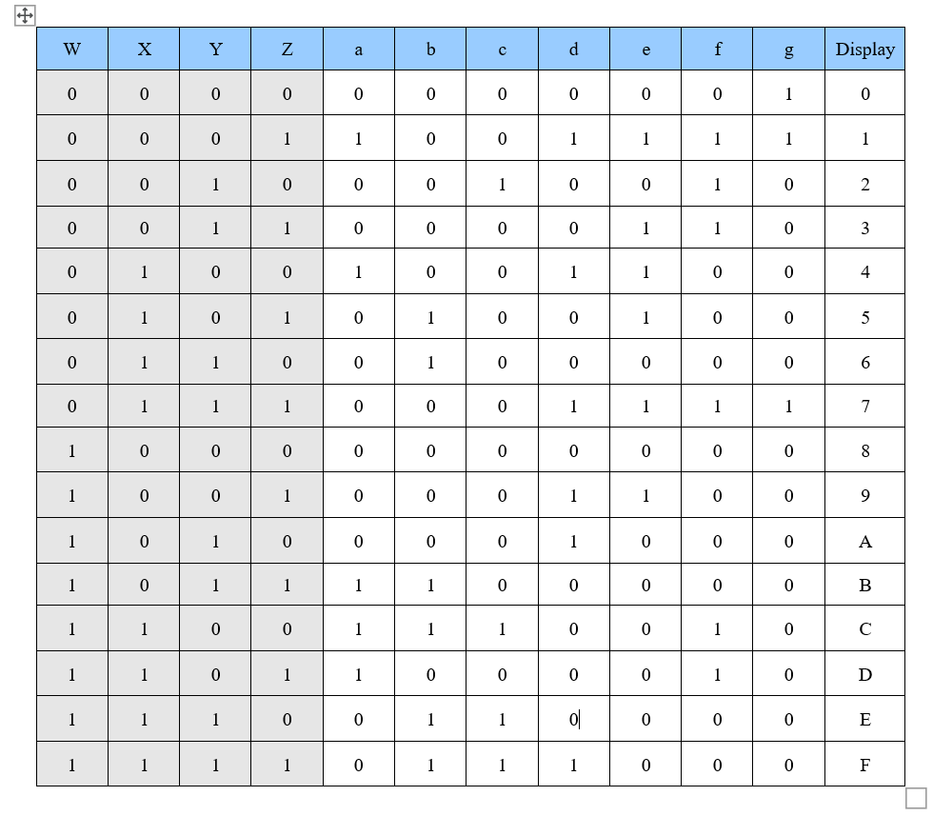

Figure 1, filled truth table values based on seven-segment display

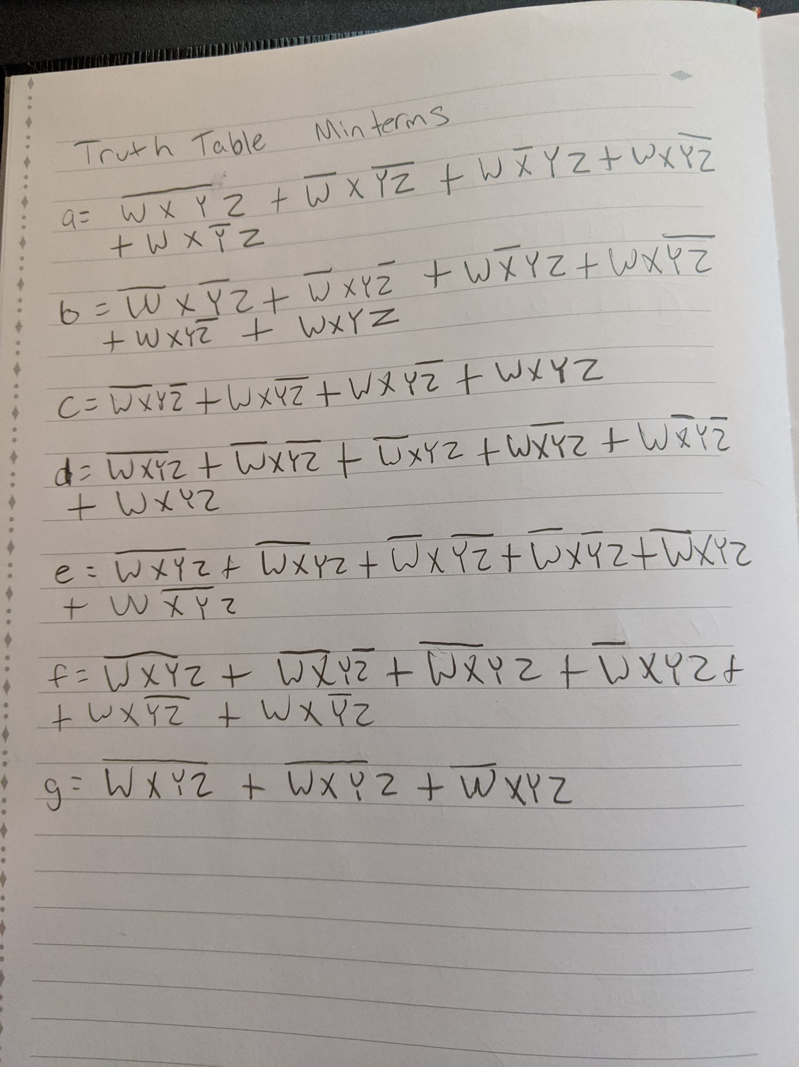

Figure 2, logic expressions (minterms) derived from figure 1 truth table

**Part 2:**

**Experiment**

The experiment in part 2 is quite simple. The goal was too make a new file and code the minterms from figure 2 into a VHDL file, of which the skeleton of code was supplied.

**Results**

The code is shown in figure 3 below, where I essentially took the minterm values from figure 2 and put them into code in figure 3.

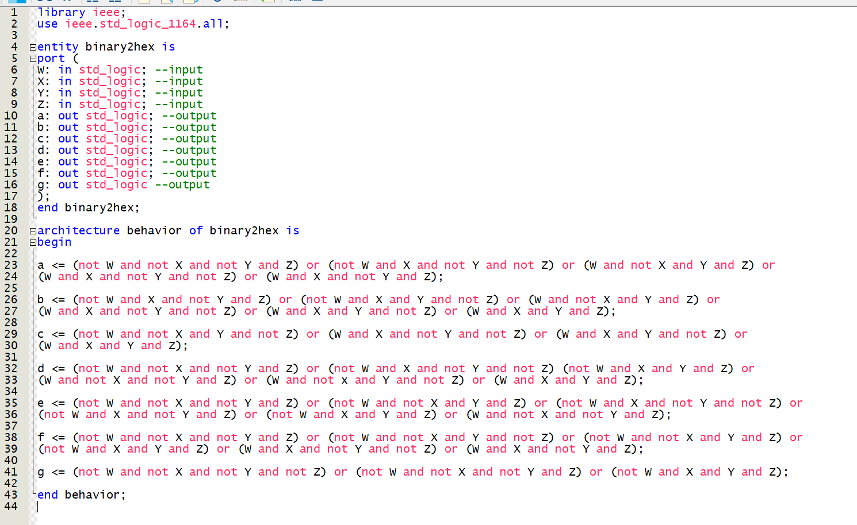

Figure 3, code as in the VHDL file

**Part 3:**

**Experiment**

The experiment in part 2 is also somewhat simple. It involves simply compiling the code from part 2 and programming into the board, which will then showcase the proper results.

**Results**

Figures 4 and 5 below showcase the results of programming the board. Specifically, A and lowercase B were asked to be displayed, so those are the two pictures taken. What I did for this part was simply follow the instructions on correctly assigning pins and programming the board. This part was nice in confirming that I had not only managed to properly code values into the VHDL file, but also that those values themselves seem to work out as I intended from the truth table and minterm expressions in figures 1 and 2.

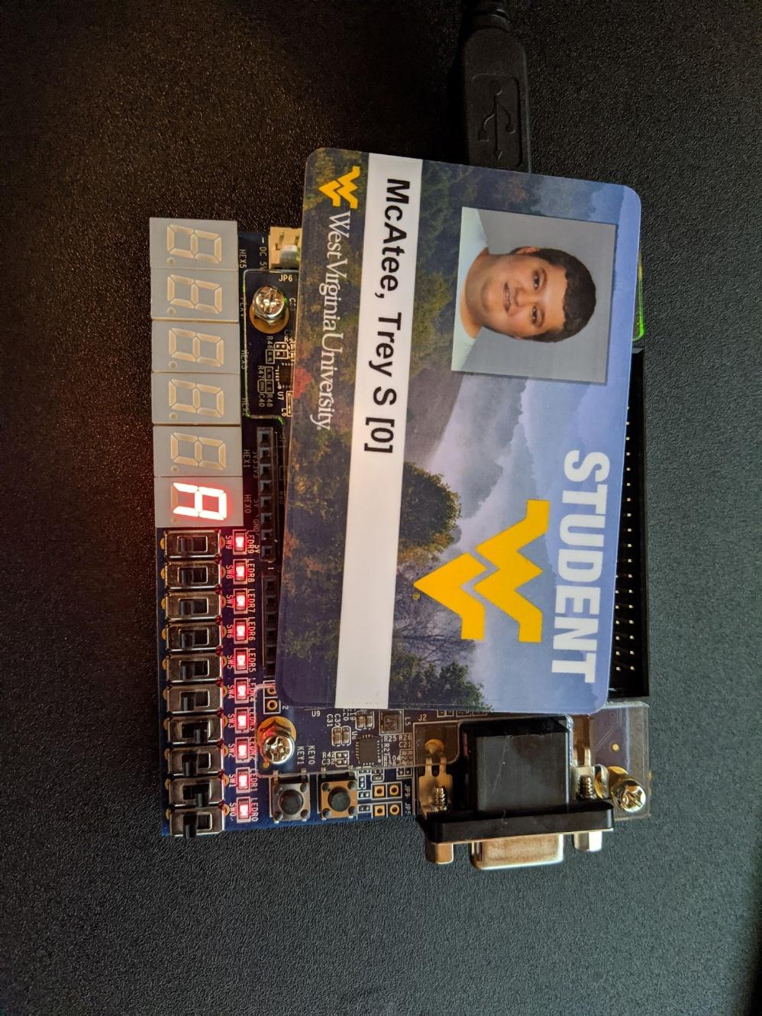

Figure 4, board displaying results of input (1010)

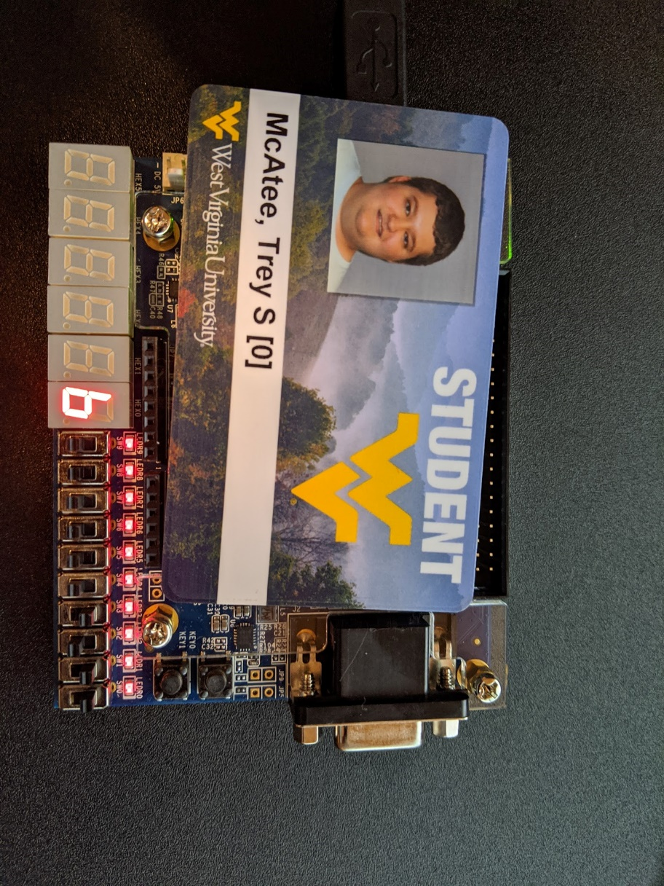

Figure 5, board displaying results of (1011)

**Conclusion:**

What I learned in this lab was how to program the board correctly (I had issues in lab 1 with part 3’s programming), and how to evaluate truth tables to a more effective degree. I was very intimidated at first seeing the figure one truth table, not immediately realizing that it really was quite easy to fill out. Understanding that a 0 equates to light on and a 1 being light off seems somewhat weird to me as well, but I got used to that after a couple of minutes. I think one way to improve this lab would be to not give any code in part 2. The VHDL language doesn’t seem tough to learn, with just a few tips in general syntax it should be somewhat easy for students to pick it up for this lab.

POST LAB QUESTIONS:

1. The common cathode has every cathode directly attached to one another, and the common anode has every anode directly attached to one another.
2. The proper sequence for “7” is “0111” in inputs and “0001111” for individual LED segments.

PRE LAB 3 QUESTIONS:

1. FPGA means “Field Programmable Gate Arrays”
2. They are more efficient.

**Designing a Binary Arithmetic Operator Using Logic Design**

Trey McAtee

CPE 272 Lab 3

9/20/2020

No Partners

**Introduction**

The third lab of CPE 272 is meant to give students an understanding of the subtracting binary numbers from each other, and how to represent it on the circuit board we were given. This is the first lab with no video walkthroughs as well, so it also serves to find if students are truly able to work with the board well.

**Part 1:**

**Experiment**

The experiment in part 1 was to fill out a truth table to find the outputs of what the circuit board should display given two binary inputs subtracted from one another, and to create a half subtractor. The outputs needed to be found are Borrow Out and Difference. Minterm equations are also expected, and finally students need to draw out the circuit diagram to represent the proper truth table behavior in Quartus.

**Results**

The filled-out truth table and minterm expressions are listed below, along with two photos showing the results of my half subtractor programming. There is also a photo of my diagram in quartus. I had some issues figuring out how I would actually display the outputs, before I realized that the LEDs just above the switches would work very well as a method of showing outputs, with 1 being on, and 0 being off.

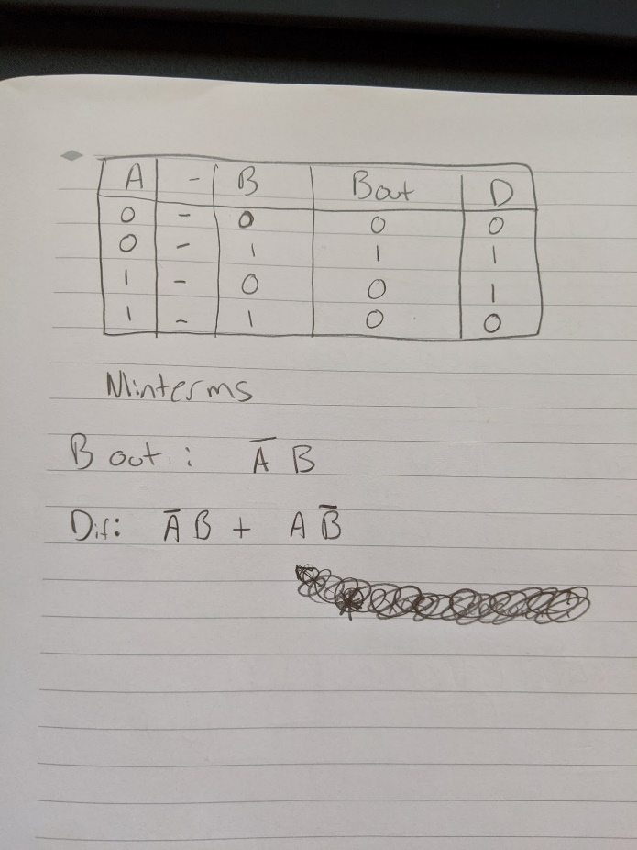

Figure 1, logic expressions (minterms) and truth table

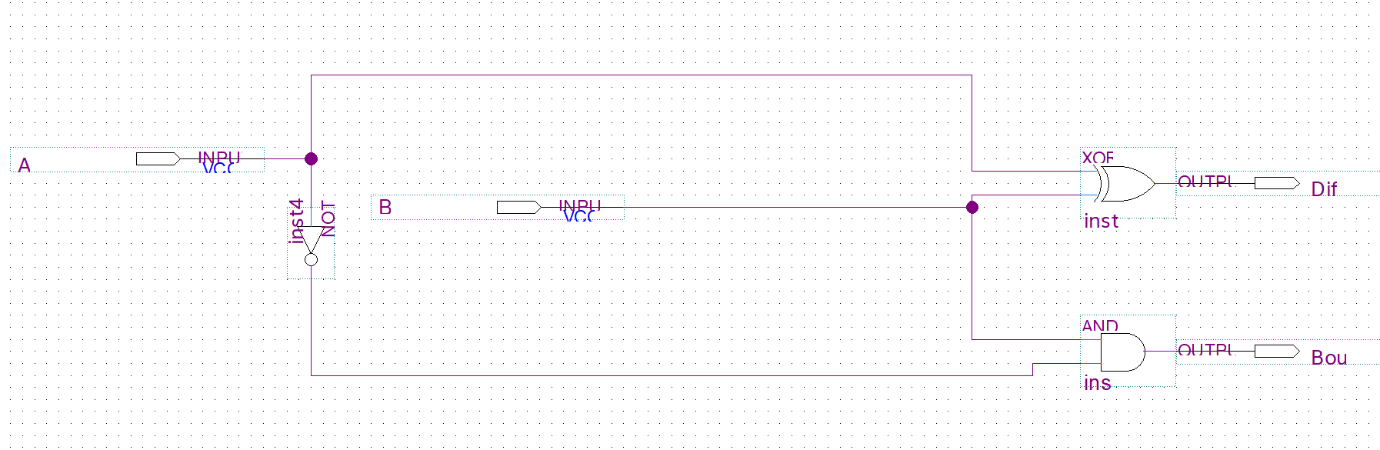

Figure 2, diagram for half subtractor as in quartus

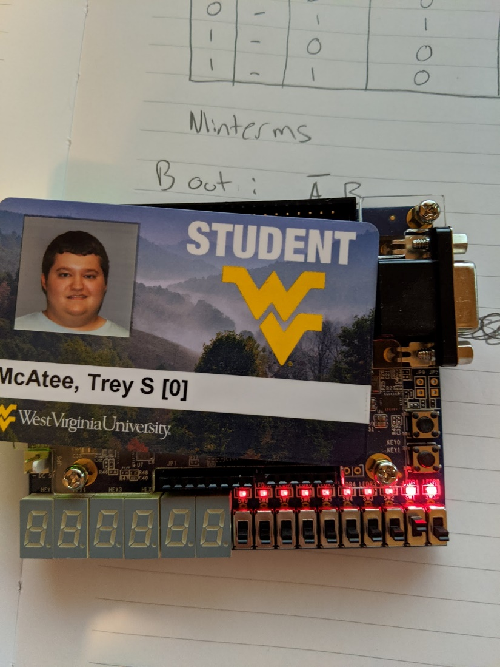

Figure 3, proof of output photo displaying results of (A=0, B=1)

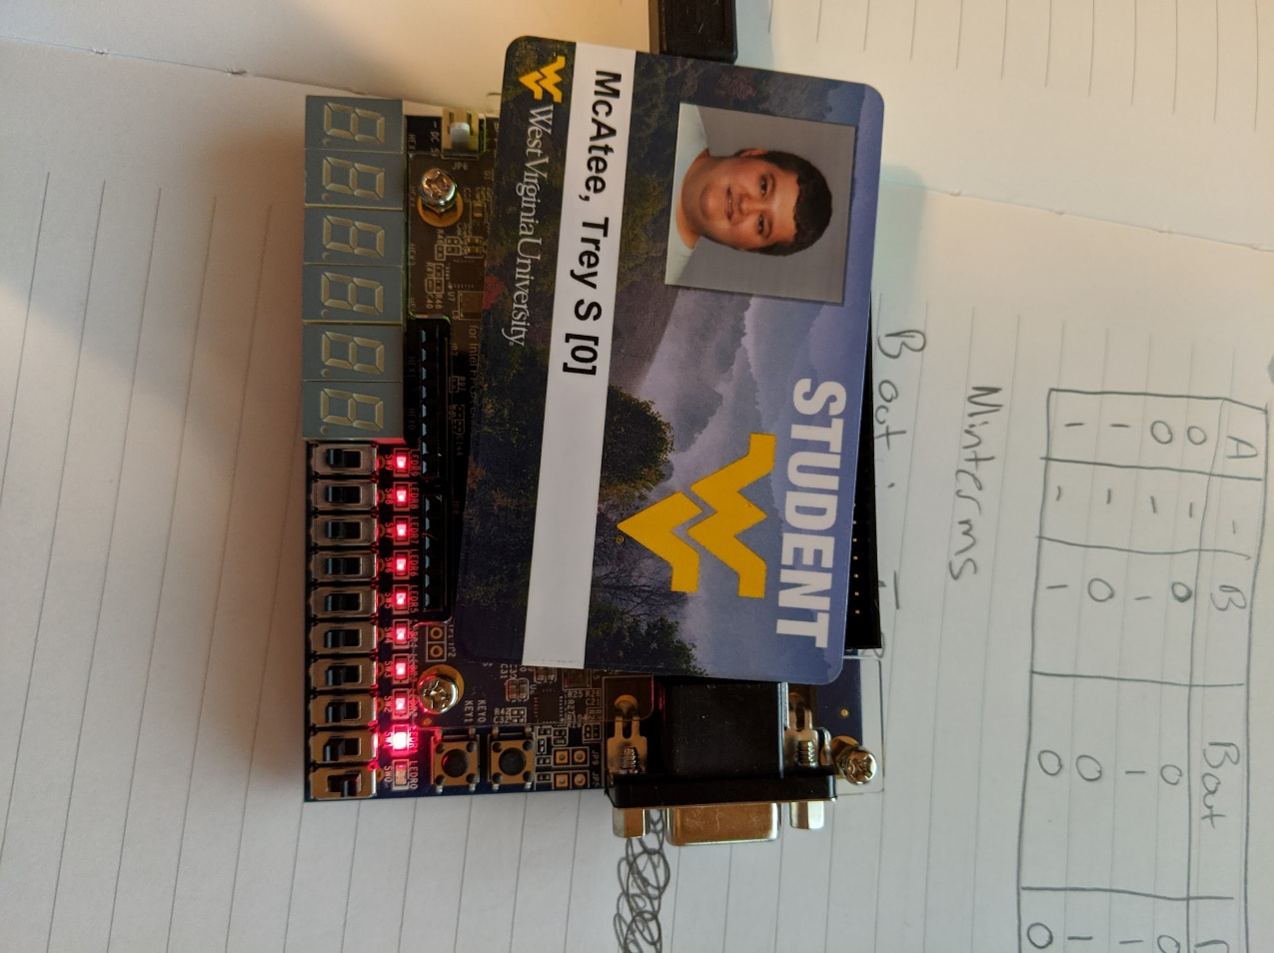

Figure 4, proof of output photo displaying results of (A=1, B=0)

**Part 2:**

**Experiment**

The experiment in part 2 is quite similar to that of part 1. We had all the same objectives, except they pertained to making a full subtractor rather than a half one.

**Results**

The filled-out truth table and minterm expressions are listed below, along with two photos showing the results of my half subtractor programming. There is also a photo of my diagram in quartus. I used the same method of displaying my outputs as in part 1, and I noticed that I could make a full subtractor by basically adding a second half subtractor onto my first one and adding an or gate along with a third input, C.

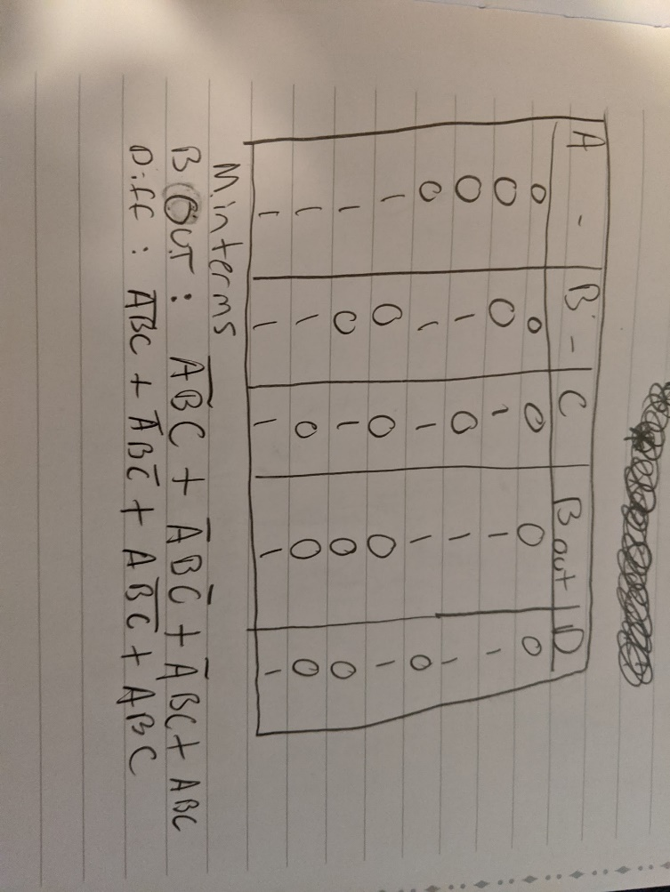

Figure 5, logic expressions (minterms) and truth table for full subtractor\

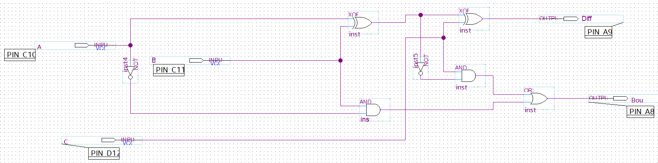

Figure 6, screenshot of full subtractor in Quartus

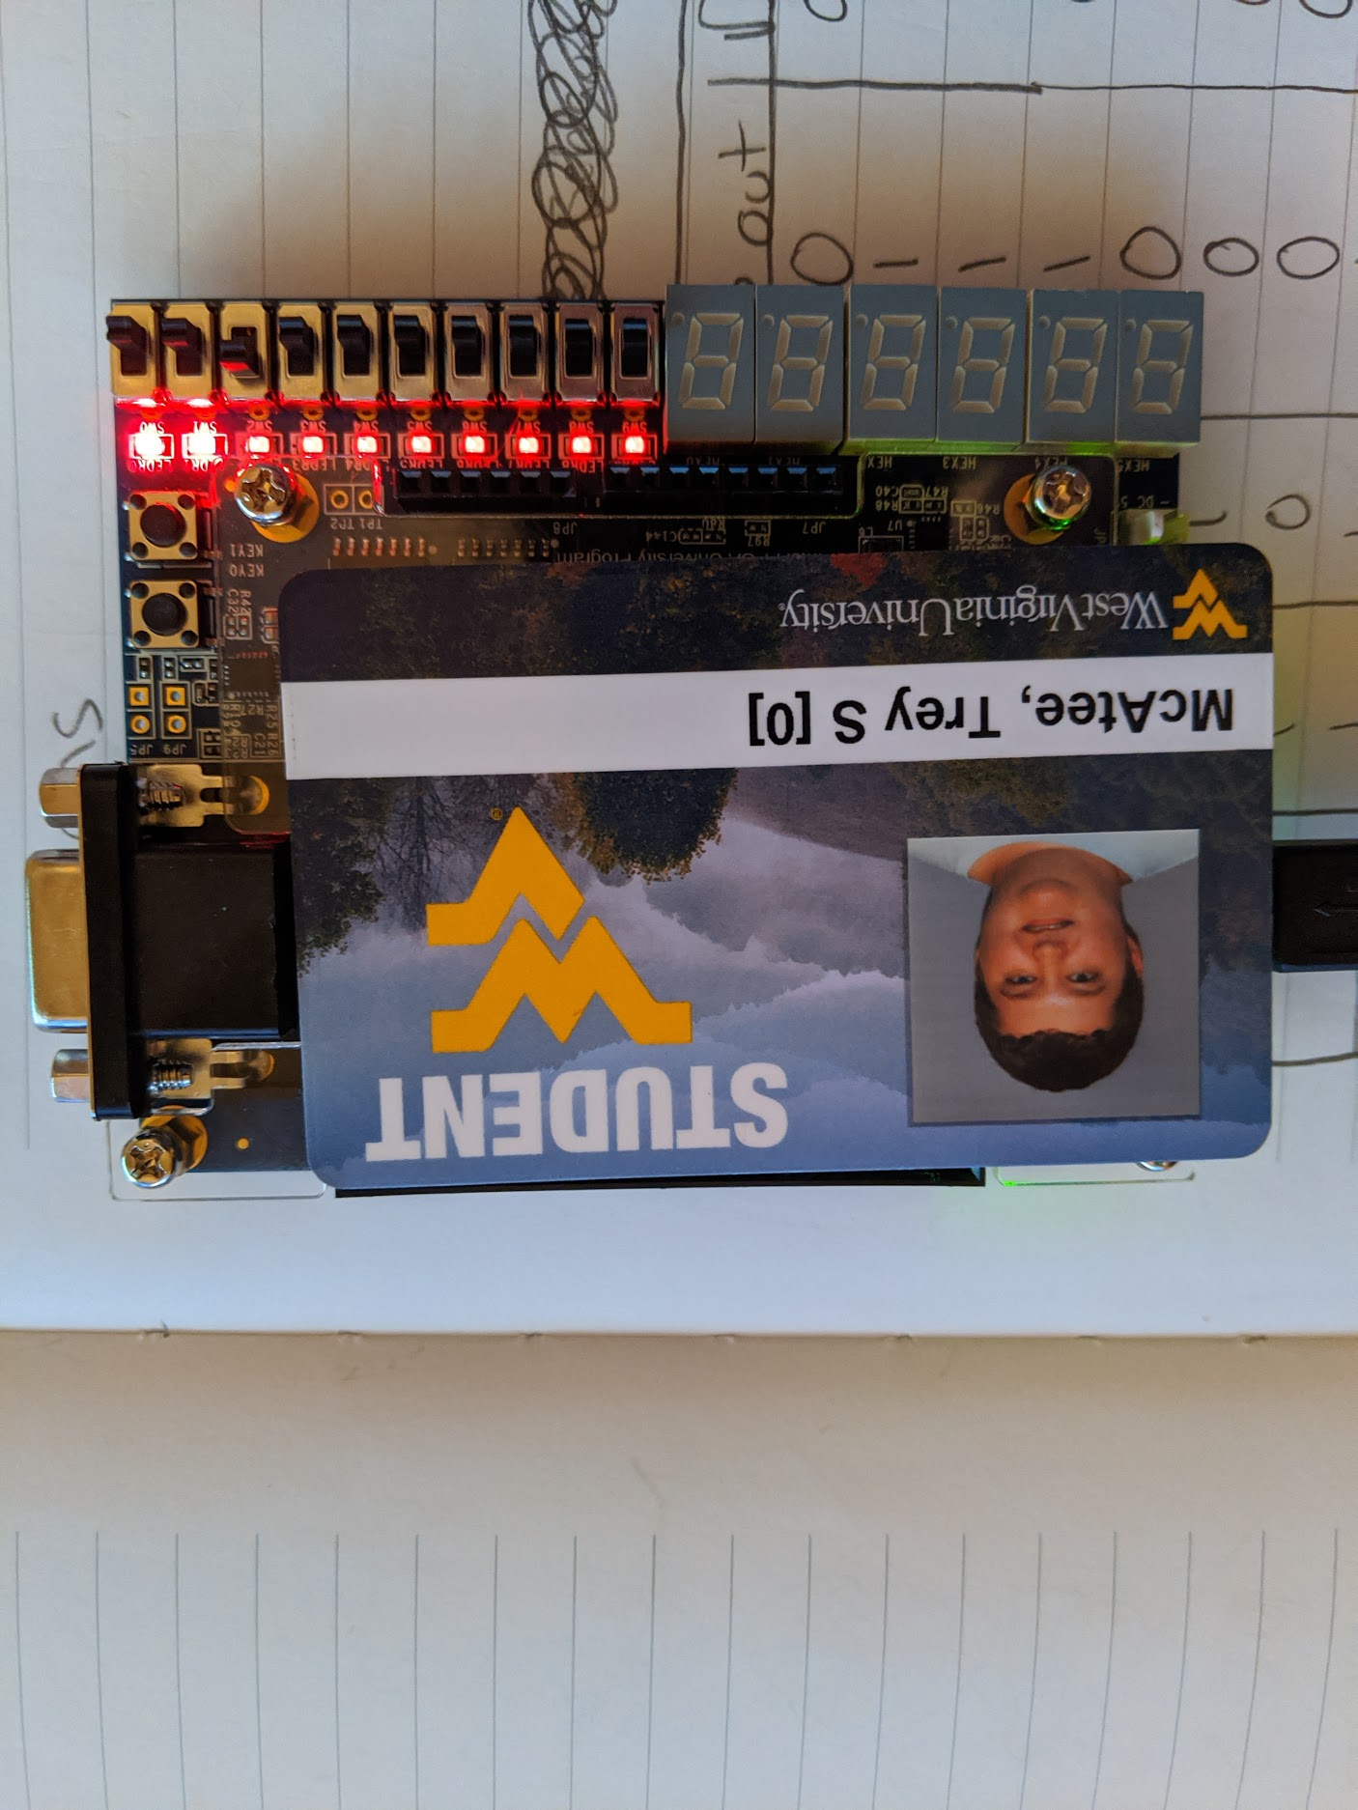

Figure 7, proof of output photo displaying results of (A=0, B=0, C=1)

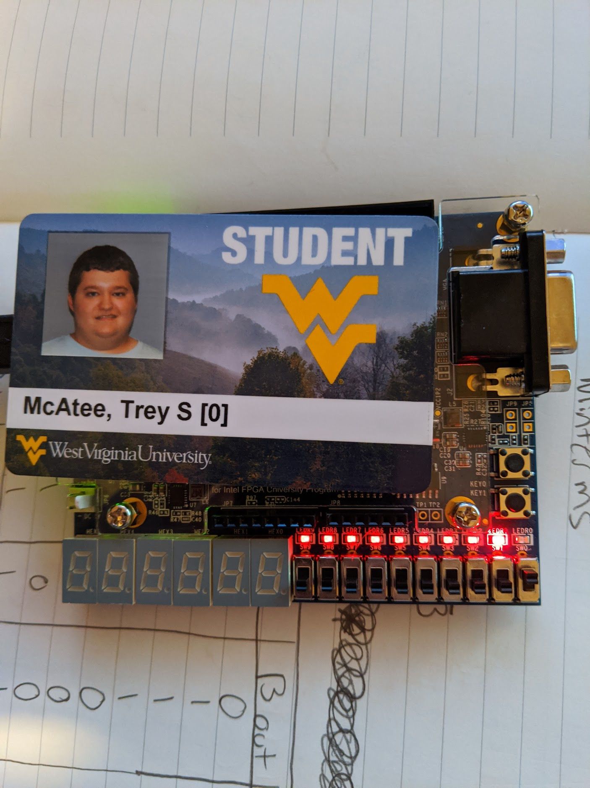

Figure 8, proof of output photo displaying results of (A=1, B=0, C=0)

**Conclusion:**

What I learned in this lab was how to program the board correctly. I thought I understood it before, but it really took me some time to figure it out without a direct walkthrough. I now understand more clearly what each pin assignment does and needed to use the manual to find the LED assignments as well. Creating a half subtractor took me some time to figure out as well, but once I understood that, it wasn’t all that difficult for me to realize a full subtractor from there in part 2. This lab definitely made me more confident in handling the circuit board. I would recommend that there be at least some sort of walkthrough on this lab, as while it did force me to learn some things myself, it really did feel like a trial by fire at least in terms of programming the board. There was a long period of time for me personally where my logic was correct but I kept questioning it because the board was incorrectly assigned pins, and I wrongly questioned the logic behind my design for a scary amount of time.

POST LAB QUESTIONS:

1. B=1, D=1
2. B=1, D=1

PRE-LAB 4 QUESTIONS:

1. VHDL means “VHSIC Hardware Description Language”
2. A binary integer
3. Single quotes ‘0’

**Introduction to VHDL**

Trey McAtee

CPE 272 Lab 4

9/27/2020

No Partners

**Introduction**

The fourth lab of CPE 272 is meant to give students an understanding of how to properly code and use the VHDL language. It also loops back to reinforce some concepts introduced in earlier labs and serves to further enhance the student’s knowledge of how to properly work with the board.

**Part 1:**

**Experiment**

The experiment in part 1 was to fill out a truth table to find the outputs of what the circuit board should display with the VHDL code supplied in the lab handout. We were also to find out what logic gate’s behavior is mimicked with this code, and then make sure the circuit board properly displays these results.

**Results**

The filled-out truth table is listed below, along with some photos showing the results of my circuit board showing the results of the code. There is also a photo of my VHDL code in quartus, that I copied from the lab handout. I used the switches SW0 and SW1 to represent x1 and x2 respectively, and LEDR0 to display the output, where “off” is ‘0’ and “on” is ‘1’. Finally, I determined that the VHDL code is mimicking the behavior of a XOR gate, because it outputs a 1 only when exactly one input is equal to 1.

|  |  |  |
| --- | --- | --- |
| Inputs | | Output |
| x1 | x2 | f |
| 0 | 0 | 0 |
| 0 | 1 | 1 |
| 1 | 0 | 1 |
| 1 | 1 | 0 |

Figure 1, part 1 truth table

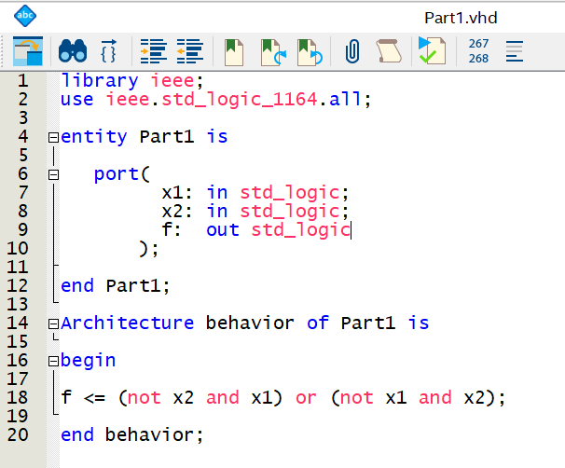

Figure 2, VHDL code in Quartus

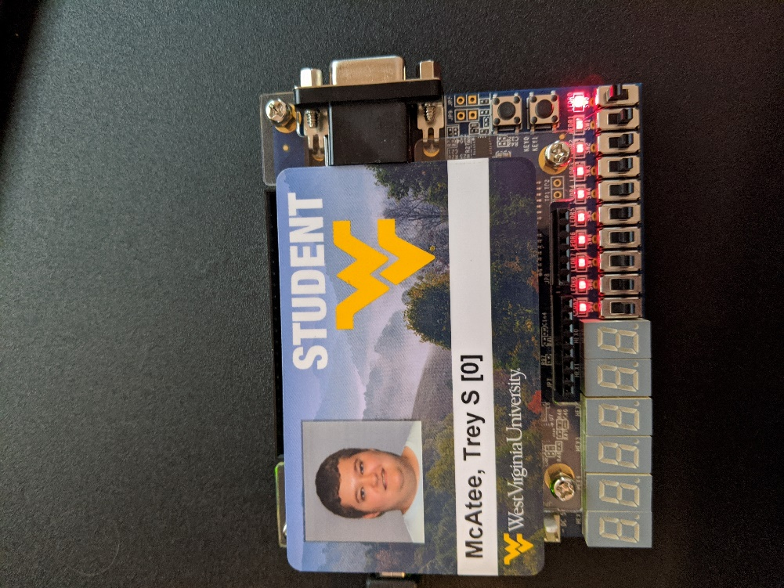

Figure 3, proof of output photo displaying results of (x1=1, x2=0)

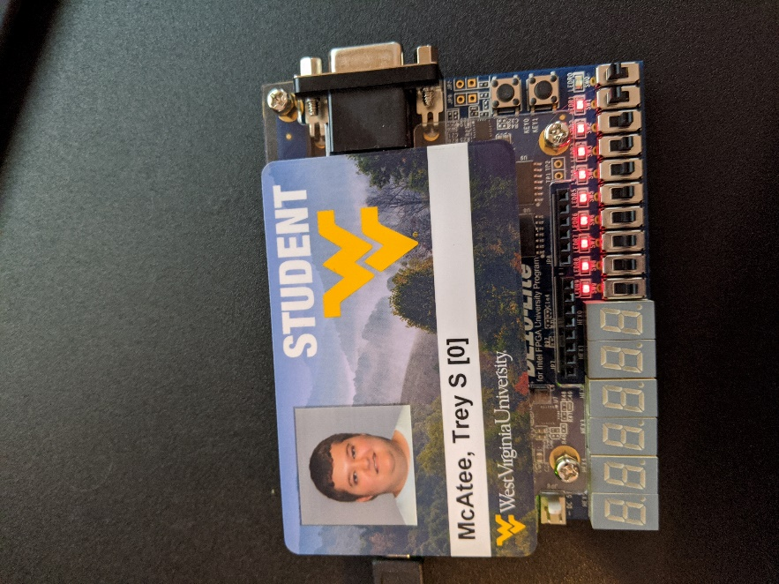

Figure 4, proof of output photo displaying results of (x1=1, x2=1)

**Part 2:**

**Experiment**

The experiment for part 2 was to take a given logic diagram and code it in VHDL. We should also fill out the truth table for all gates and output values and show that the circuit board correctly displays these outputs.

**Results**

To code the logic diagram given, I found the minterms from the truth table and have them listed below. Also, I designated LEDR0 to be my output LED again, while SW0, SW1, and SW2 were assigned A, B, and C respectively. Pictures of my truth table, logic diagram, VHDL code, and the circuit board are shown below. My minterms are listed out in the VHDL code snippet.

|  |  |  |  |  |  |  |
| --- | --- | --- | --- | --- | --- | --- |
| Inputs | | | Intermediary | | | Output |
| A | B | C | G1= | G2= | G3= | Y= |
| 0 | 0 | 0 | 1 | 0 | 1 | 1 |
| 0 | 0 | 1 | 1 | 0 | 1 | 1 |
| 0 | 1 | 0 | 1 | 1 | 1 | 1 |
| 0 | 1 | 1 | 1 | 1 | 1 | 1 |
| 1 | 0 | 0 | 0 | 0 | 1 | 1 |
| 1 | 0 | 1 | 0 | 0 | 0 | 0 |
| 1 | 1 | 0 | 0 | 0 | 1 | 1 |
| 1 | 1 | 1 | 0 | 0 | 0 | 0 |

Figure 5, part 2 truth table

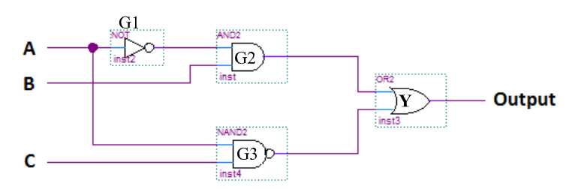

Figure 6, logic diagram from lab handout

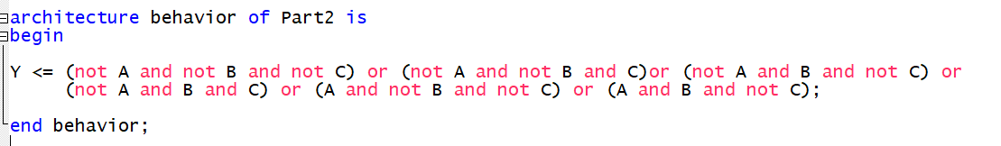

Figure 7, VHDL code snippet with minterms

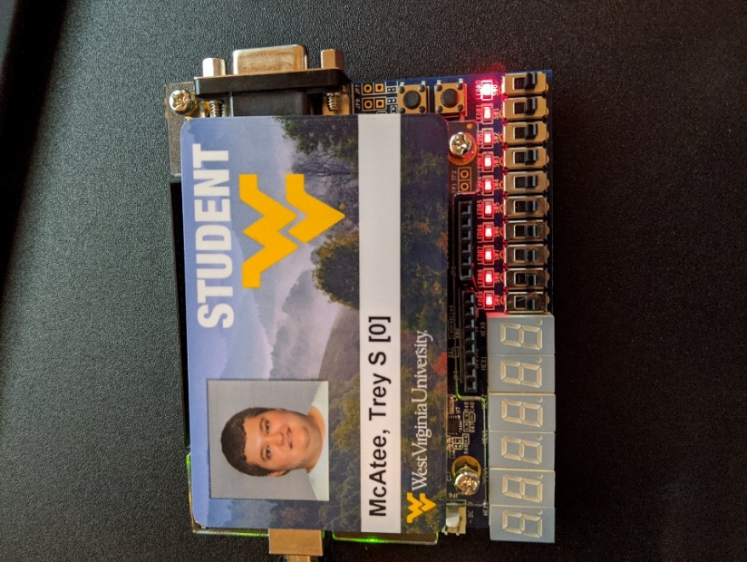

Figure 8, proof of output photo displaying results of (A=0, B=0, C=0)

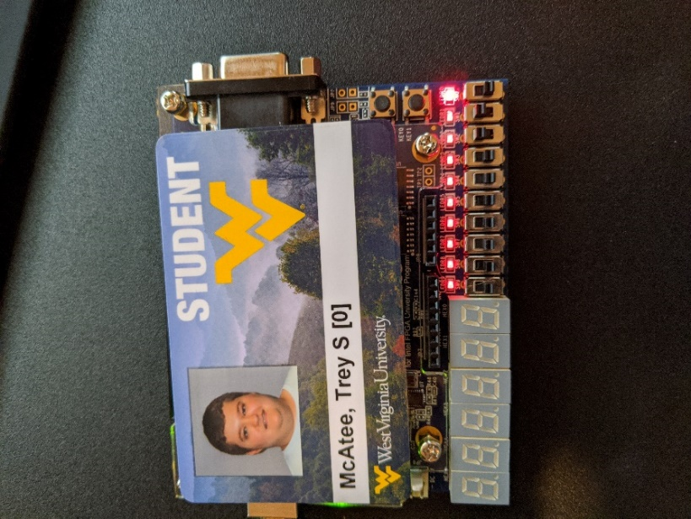

Figure 9, proof of output photo displaying results of (A=0, B=1, C=1)

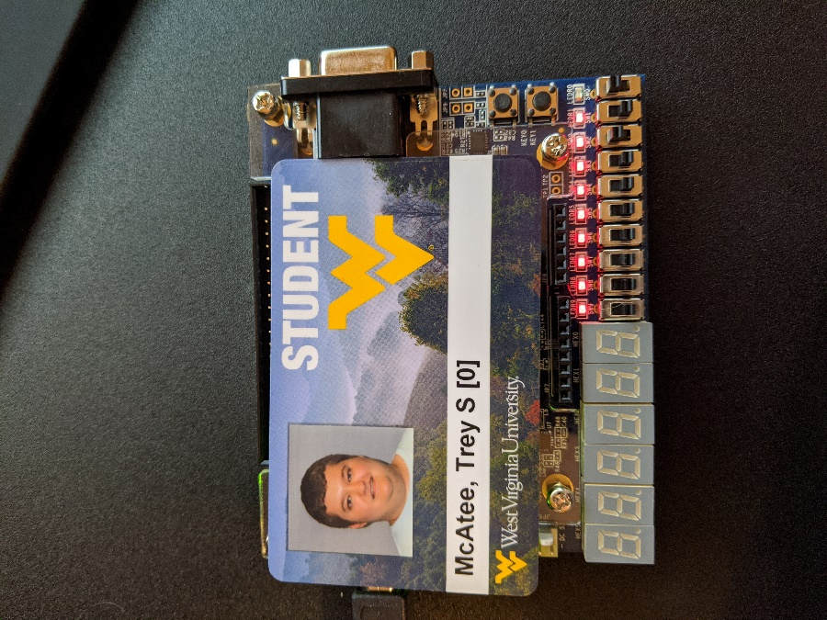

Figure 10, proof of output photo displaying results of (A=1, B=0, C=1)

**Part 3:**

**Experiment**

The experiment for part 3 was create a full binary adder in VHDL to take two 3-bit numbers and add them together. There was also a truth table to fill out to obtain equations for sum and carry outputs. Then, choose two 3-bit binary numbers and display their outputs on the circuit board.

**Results**

The first thing I did for this part was fill out the truth table with proper outputs, and then find the minterm equations. Next, I coded the VHDL file. This step took me an incredible amount of time, as I could not wrap my head around how to code this part according to the lab handout. After some googling on signals in VHDL and scanning through the lab 5 handout, however, I found a way to code this in VHDL that made much more sense to me. This method, while not what was listed in this lab’s handout, still works out by displaying the outputs correctly. This part is the sole reason my lab report is turned in late, and it may have been later if I did not decide to use what is shown in the lab 5 report. Shown in figures below is the original truth table along with minterm equations, another truth table showing two binary addition combinations that I chose to represent, and then pictures of the board showing that representation. My VHDL code is also shown. To quickly explain how I set up the pins, SW0 through SW2 represent x1, while SW3 through SW5 represent x2, where x1 and x2 are my two input numbers. The inputs are handled like so: if I want the binary number 101, then x1[2] is assigned the leftmost 1, x1[1] is assigned the 0, and x1[0] is assigned the rightmost 1. I used this scheme for x2 as well, and sum is represented in a similar manner but using only the LEDs, and if there is an overflow to the 4th bit position, then the leftmost LED is activated.

|  |  |  |  |  |
| --- | --- | --- | --- | --- |
| Inputs | | | Outputs | |
| A | B | C | Sum | Carry |
| 0 | 0 | 0 | 0 | 0 |
| 0 | 0 | 1 | 1 | 0 |
| 0 | 1 | 0 | 1 | 0 |
| 0 | 1 | 1 | 0 | 1 |
| 1 | 0 | 0 | 1 | 0 |
| 1 | 0 | 1 | 0 | 1 |
| 1 | 1 | 0 | 0 | 1 |
| 1 | 1 | 1 | 1 | 1 |

Figure 11, part 3 Truth Table

$$Sum=A⨁B⨁C$$

$Carry=AB+BC+AC+ABC$

Figure 12, sum and carry minterm equations

|  |  |  |  |  |  |  |  |  |  |
| --- | --- | --- | --- | --- | --- | --- | --- | --- | --- |
| Binary Addition Inputs | | | | | | Outputs | | | |
| x1 | | | x2 | | | Carry | Sum | | |
| x1[2] | x1[1] | x1[0] | x2[2] | x2[1] | x2[0] |
| 1 | 1 | 1 | 1 | 1 | 1 | 1 | 1 | 1 | 0 |
| 0 | 1 | 1 | 0 | 1 | 0 | 0 | 1 | 0 | 1 |

*table shown so that full 3-bit binary integer can be read left to right if cells were merged, and if the carry column has a 1 it is meant to be apart of the sum binary number as a new 4th bit position

Figure 13, binary addition combinations

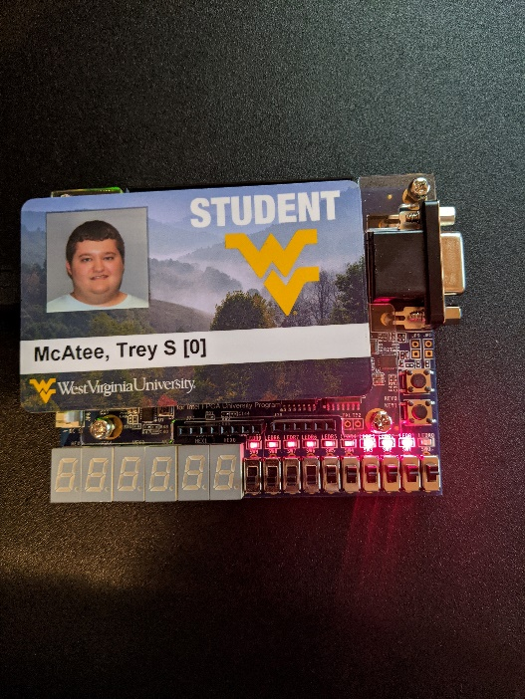

Figure 14, output photo for (111+111)



Figure 15, output photo for (011+010)

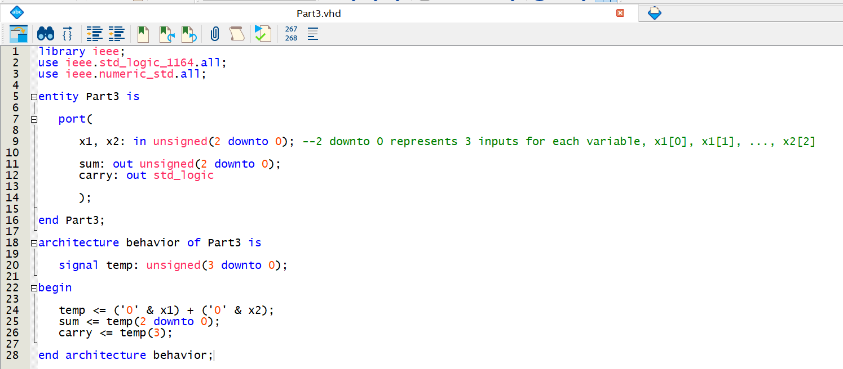

Figure 16, part 3 VHDL code

**Conclusion:**

What I learned in this lab was how to perform more complex operations in VHDL. While admittedly, I was unable to do part 3 as it was listed in the lab handout, I was still able to get working code to program the board to a functioning state. I cannot really explain what was so confusing about the explanation of how to code in part 3. However, I could recommend that to improve the lab going into detail with how to get some of the equations to start off may be useful. There was one equation given in part 3, so I tried to figure out how that equation was obtained so that I may be able to find the others, but I could not visualize it. Creating the full adder once I saw lab 5’s handout however really was far easier to think about. As for parts one and two, they were both somewhat easy to figure out and code in the VHDL format. My only and biggest recommendation for this lab would be to find a way to maybe go into more detail with the explanation of part 3, the hardest part for me really was just trying to conform to how the lab handout specified for how to code it.

POST LAB QUESTIONS:

1.

|  |  |  |  |  |  |  |
| --- | --- | --- | --- | --- | --- | --- |
| Inputs | Output Steps (Gates -> Output) | | | | | |
| ABC | Top NOT | Bot NOT | NOR | NAND | XOR | Output |
| 000 | 1 | 1 | 0 | 1 | 1 | 1 |
| 001 | 1 | 0 | 0 | 1 | 1 | 1 |
| 010 | 1 | 1 | 0 | 0 | 0 | 0 |
| 011 | 1 | 0 | 0 | 1 | 1 | 1 |
| 100 | 0 | 1 | 1 | 1 | 0 | 0 |
| 101 | 0 | 0 | 1 | 1 | 0 | 0 |
| 110 | 0 | 1 | 0 | 0 | 0 | 0 |
| 111 | 0 | 0 | 0 | 1 | 1 | 1 |

2. 11100 10111

+ 01001 + 01011

= 100101 =100010

Both carried one over to the 6th bit

PRE-LAB 5 QUESTIONS:

1. Logic simulation is when you create a simulation to predict how a circuit would work
2. Modular design is basically creating a thing by dividing it into multiple smaller pieces (modules) and piecing each module together to actually make the thing. Making a structure with Legos could be an example of this.
3. Architecture statement

**Introduction to Logic Simulation**

**and**

**Modular Design**

Trey McAtee

CPE 272 Lab 5

10/4/2020

No Partners

**Introduction**

The fifth lab of CPE 272 is meant to give students an understanding of logic simulation and modular design, and how to use it in quartus. It also reinforces past concepts introduced by coding VHDL and also goes back to show other ways of accomplishing tasks completed in past labs.

**Part 1:**

**Experiment**

The experiment in part 1 was to create a XNOR gate behavior in VHDL and verify the results using the built in quartus waveform simulator.

**Results**

The filled-out truth table is listed below for what values a XNOR gate should output along with a photo showing both my VHDL code and the waveform simulator output. I simply verified the waveform simulator results with that of my truth table before moving on to the next part.

|  |  |  |
| --- | --- | --- |
| Inputs | | Output |
| x1 | x2 | f |
| 0 | 0 | 1 |
| 0 | 1 | 0 |
| 1 | 0 | 0 |
| 1 | 1 | 1 |

Figure 1, part 1 truth table

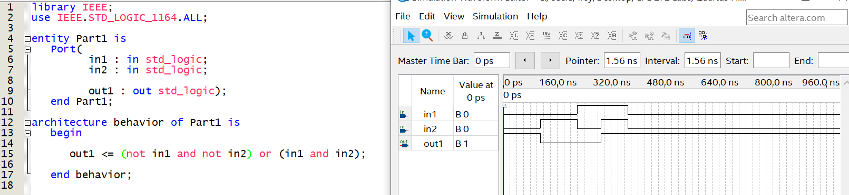

Figure 2, part 1 VHDL Code and Waveform simulator results

**Part 2:**

**Experiment**

The experiment for part 2 was to take the VHDL code of a 3-bit adder from part 3 of lab 4 and recreate it using a different technique. Then, verify the results using the waveform simulator.

**Results**

To code the 3-bit adder in the newer format, I took my previous code and made some minor edits. I imported a new library and swapped my formerly unsigned variables to a vector type. Other than that, the code is the same. I verified the results with the waveform simulator as well, and pictures of both my VHDL code and the simulated results are below.

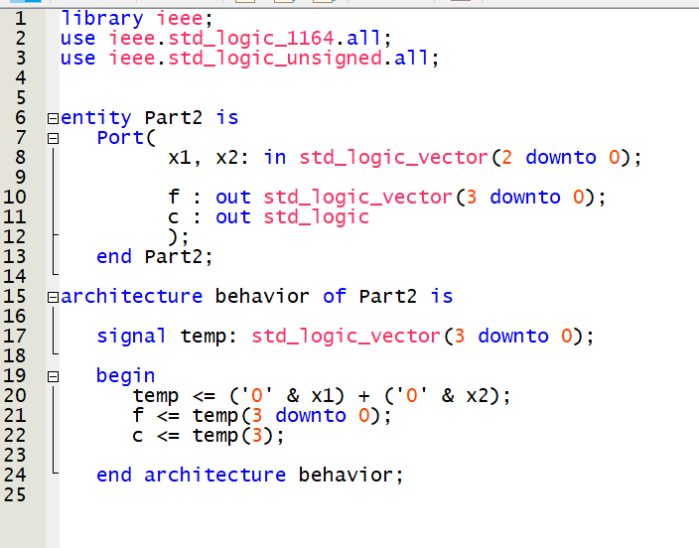

Figure 3, part 2 VHDL Code

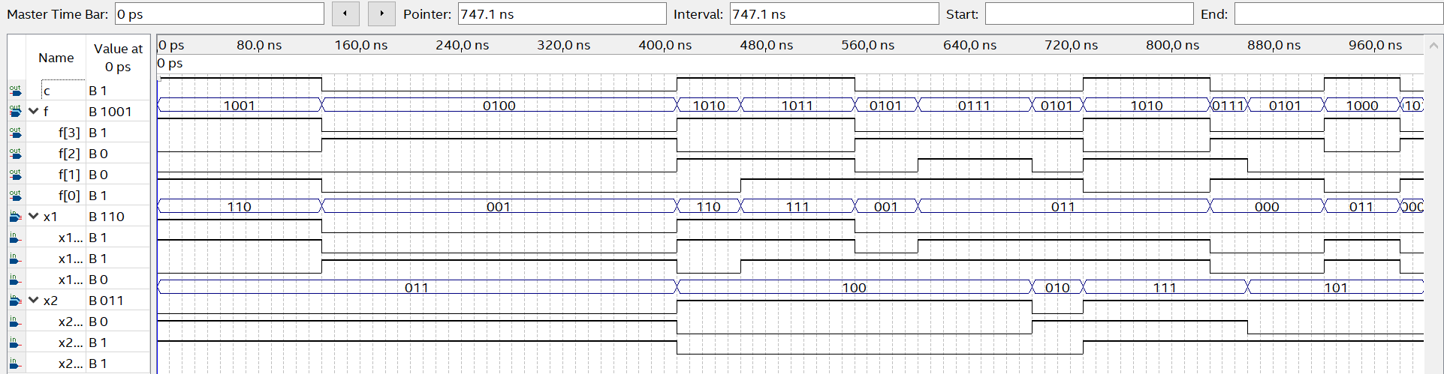

Figure 4, part 2 Waveform simulator results

**Part 3:**

**Experiment**

The experiment for part 3 was create a one-bit full binary adder in VHDL to be used later in part 4 of this lab. There is a truth table and logic expressions to find as well.

**Results**

I took the truth table and logic expressions from my previous lab. I also put a picture of my VHDL code for this part.

|  |  |  |  |  |
| --- | --- | --- | --- | --- |
| Inputs | | | Outputs | |
| A | B | C | Sum | Carry |
| 0 | 0 | 0 | 0 | 0 |
| 0 | 0 | 1 | 1 | 0 |
| 0 | 1 | 0 | 1 | 0 |
| 0 | 1 | 1 | 0 | 1 |
| 1 | 0 | 0 | 1 | 0 |
| 1 | 0 | 1 | 0 | 1 |
| 1 | 1 | 0 | 0 | 1 |
| 1 | 1 | 1 | 1 | 1 |

Figure 5, part 3 Truth Table

$$Sum=A⨁B⨁C$$

$Carry=AB+BC+AC+ABC$

Figure 6, part 3 logic expressions

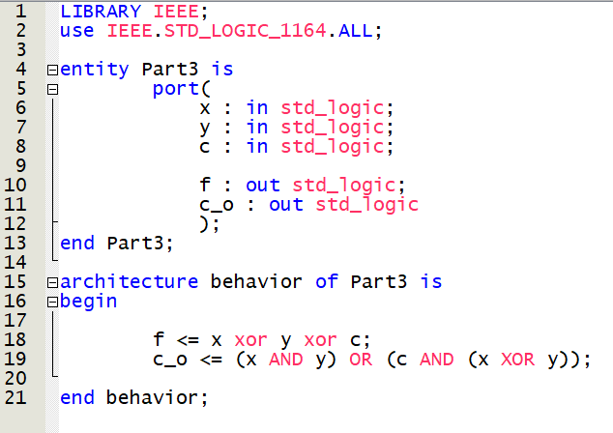

Figure 7, VHDL Code

**Part 4:**

**Experiment**

The experiment for part 4 was import the code from part 3 and use it to accomplish a multi bit adder.

**Results**

For this part, I took some time to properly figure out the code for using another set of code, and then I just went ahead and simulated the results on the waveform simulator once my code compiled correctly. I recorded some of the results of my adder in the below table, and then confirmed them myself by writing them out by hand. Photos of my VHDL code, the table, and the waveform simulation results are posted below.

|  |  |  |
| --- | --- | --- |
| Binary Addition Inputs | | Output |
| Inputs (x3,x2,x1,x0) | Inputs (y3,y2,y1,y0) | Output (f4,f3,f2,f1,f0) |
| 1111 | 0111 | 10110 |
| 0110 | 1100 | 10010 |

Figure 8, part 4 results table

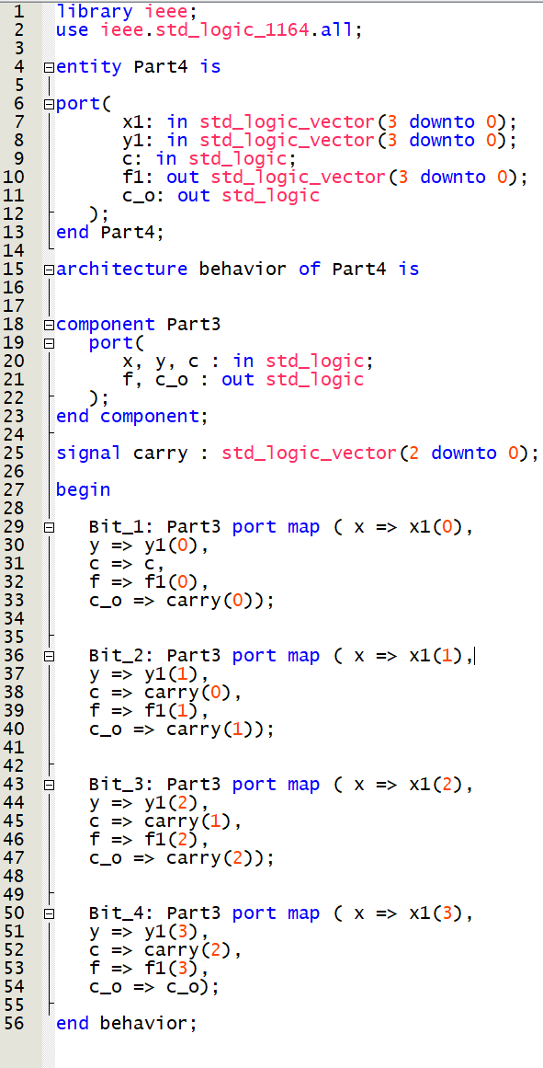

Figure 9, part 4 VHDL Code

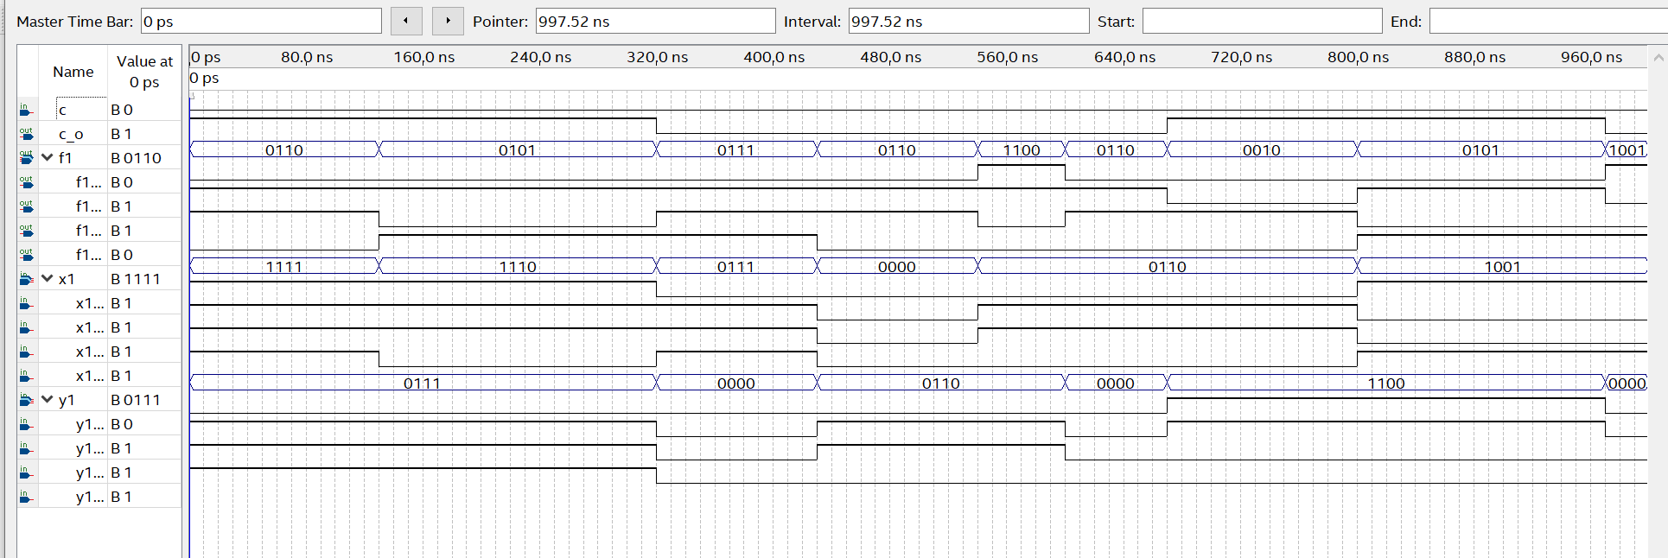

Figure 10, part 4 simulated results

**Conclusion:**

What I learned in this lab was how to perform even more complex operations in VHDL. It took some time to get the port mapping statements correct, there were seemingly endless syntax errors for me. Besides that, however, I was able to successfully create a full adder again using the more complex VHDL statements. My recommendation for this lab would be to require students to confirm their results on the board as well, so that they can see truly that the simulation works correctly.

POST LAB QUESTIONS:

1. Signal signal_carry : std_logic_vector (7 downto 0);
2. Errors listed by letter
3. In entity postlab port, topEntityOut_2 has a semicolon at the end where there shouldn’t be
4. In add1, no semicolon and no closing )
5. In the final sum, => is used instead of the correct :
6. In the final sum, there is no beginning (

PRE-LAB 6 QUESTIONS:

No post lab questions ?

**Behavioral Modeling of Combinational**

**Logic Circuits Using VHDL – I**

Trey McAtee

CPE 272 Lab 6

10/11/2020

No Partners

**Introduction**

The sixth lab of CPE 272 is meant to give students a more advanced level of understanding of VHDL code and how it can be implemented to represent different scenarios. It also reinforces past concepts introduced by coding VHDL such as logic vectors.

**Part 1:**

**Experiment**

The experiment for part 1 was to make a simple priority encoder. We have also been introduced to a new type of statement in VHDL that we must utilize in the creation of the priority encoder, conditional statements. With the new if/elsif/else structure, we can code in more complex operations for the board to interpret and visualize.

**Results**

I filled out the truth table that corresponds to the 3-input, two output priority encoder and listed it below, understanding that the output would effectively represent the index position of the highest logic high input. Next, I went to Quartus to code the interpretation of the truth table. In my conditional statements, I used an if/elsif/elsif/else structure, because I thought that would be the most efficient way of going about this. I used one simple check at each stage, starting out by checking if x(2) is equal to one. In that case, we don’t care what x(1) and x(0) are, and the output should represent that x(2) is logic high. I followed this logic for the next two elsif statements for x(1) and x(0) respectively because of the order the statements would be reached. Finally, I ended with an else statement that represents the 000-input case, as it would then be the last possible case we care about representing.

|  |  |  |  |  |
| --- | --- | --- | --- | --- |
| Inputs | | | Outputs | |
| X2 | X1 | X0 | F1 | F0 |
| 0 | 0 | 0 | 0 | 0 |
| 0 | 0 | 1 | 0 | 1 |
| 0 | 1 | 0 | 1 | 0 |
| 0 | 1 | 1 | 1 | 0 |
| 1 | 0 | 0 | 1 | 1 |
| 1 | 0 | 1 | 1 | 1 |
| 1 | 1 | 0 | 1 | 1 |
| 1 | 1 | 1 | 1 | 1 |

Figure 1, part 1 truth table

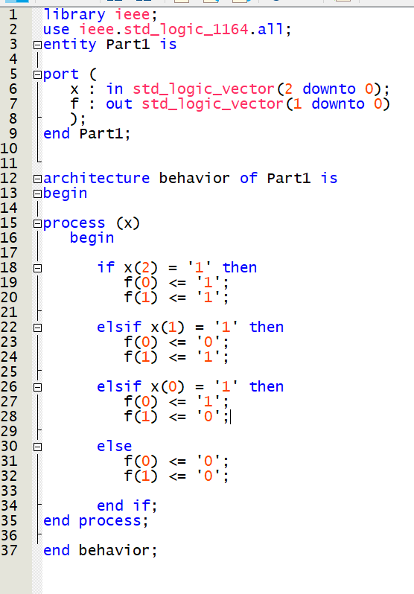

Figure 2, part 1 VHDL Code

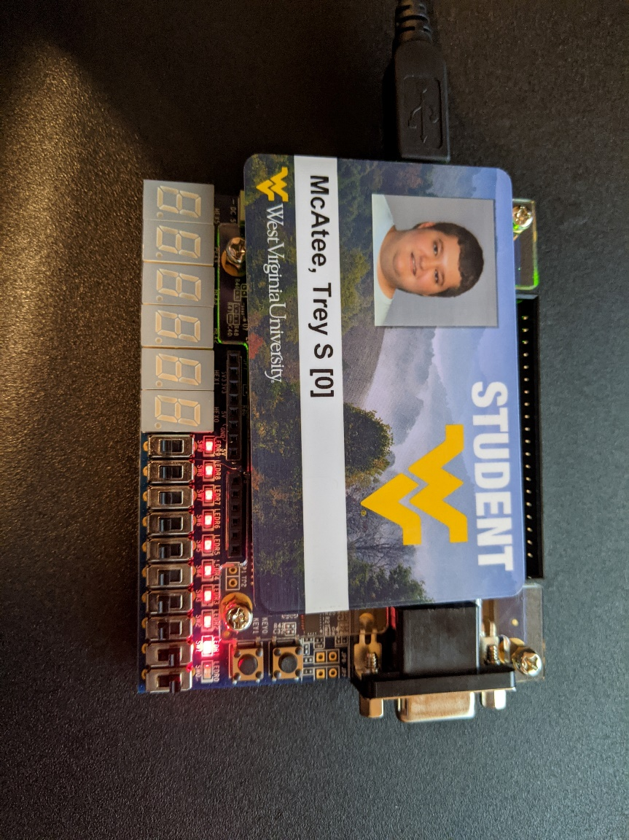

Figure 3, part 1 board results in (011) out (10)

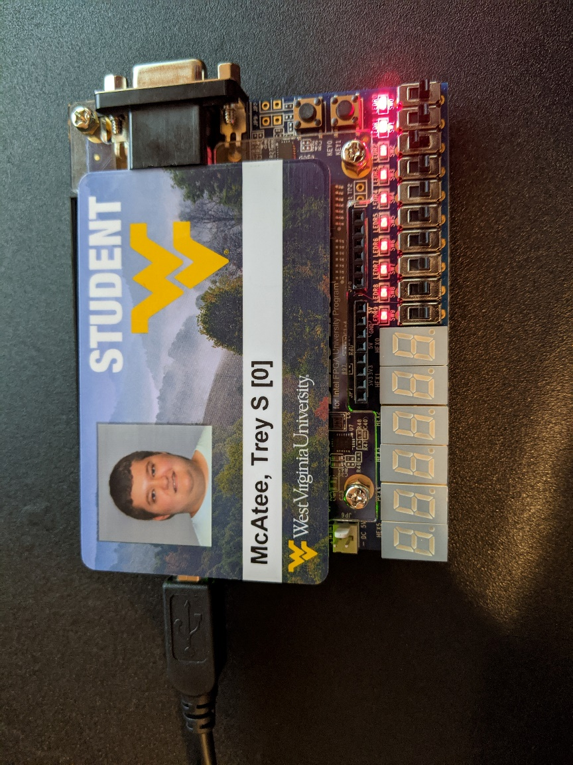

Figure 4, part 1 board results in (100) out (11)

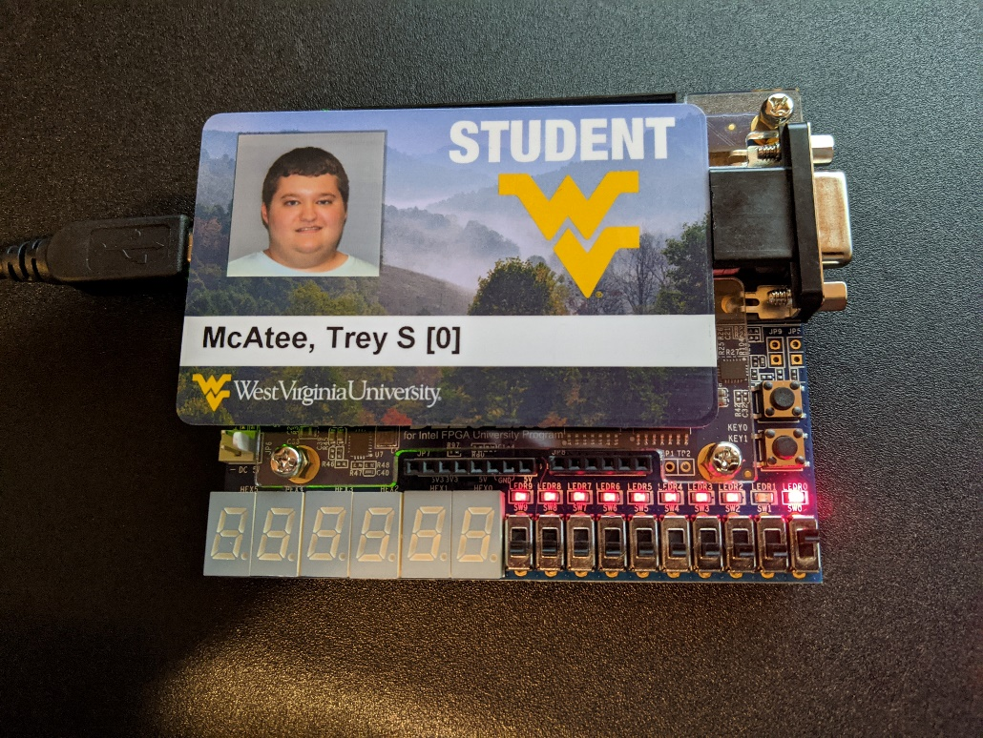

Figure 5, part 1 board results in (001) out (01)

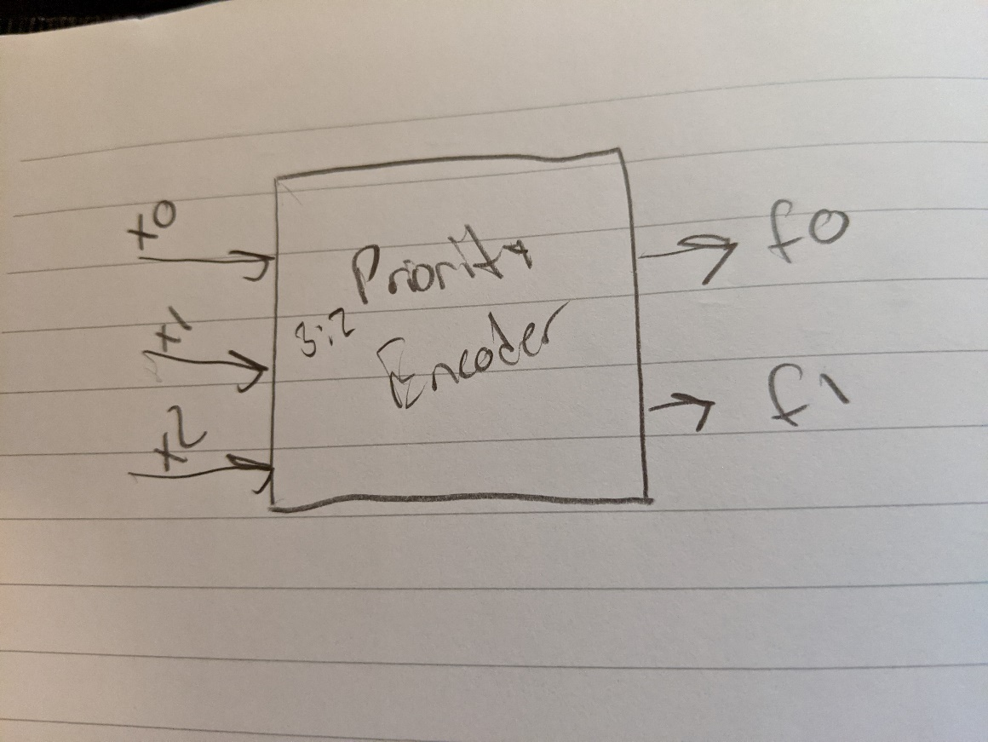

Figure 6, part 1 block diagram

**Part 2:**

**Experiment**

The experiment for part 2 was create a 3:8 active high decoder. We must fill out a truth table to help visualize what the output of the board should represent, and code the structure in VHDL format. We must also create a block diagram to represent the structure, and finally program the board to accurately represent the results.

**Results**

I immediately did two things when approaching this part. First, I drew out the block diagram for a 3:8 active high decoder. Then, I attempted to fill out the truth table to represent what the outputs should be so I can actually go to code the structure in VHDL. Next, I coded the structure by just hardcoding in every situation from the truth table. I then programmed the board to replicate this behavior and took photos to prove the results. I have listed photos of the truth table, block diagram, VHDL code snippet, and 3 scenarios that I tested on the board. For the record, I tested every scenario, but only listed 3 for the sake of brevity on this lab report.

|  |  |  |  |  |  |  |  |  |  |  |
| --- | --- | --- | --- | --- | --- | --- | --- | --- | --- | --- |
| Inputs | | | Outputs | | | | | | | |
| X2 | X1 | X0 | Y7 | Y6 | Y5 | Y4 | Y3 | Y2 | Y1 | Y0 |
| 0 | 0 | 0 | 1 | 1 | 1 | 1 | 1 | 1 | 1 | 0 |
| 0 | 0 | 1 | 1 | 1 | 1 | 1 | 1 | 1 | 0 | 1 |
| 0 | 1 | 0 | 1 | 1 | 1 | 1 | 1 | 0 | 1 | 1 |
| 0 | 1 | 1 | 1 | 1 | 1 | 1 | 0 | 1 | 1 | 1 |
| 1 | 0 | 0 | 1 | 1 | 1 | 0 | 1 | 1 | 1 | 1 |
| 1 | 0 | 1 | 1 | 1 | 0 | 1 | 1 | 1 | 1 | 1 |
| 1 | 1 | 0 | 1 | 0 | 1 | 1 | 1 | 1 | 1 | 1 |
| 1 | 1 | 1 | 0 | 1 | 1 | 1 | 1 | 1 | 1 | 1 |

Figure 7, part 2 truth table

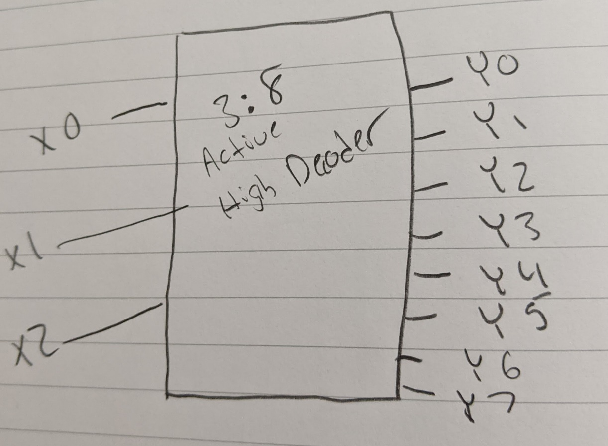

Figure 8, part 2 block diagram

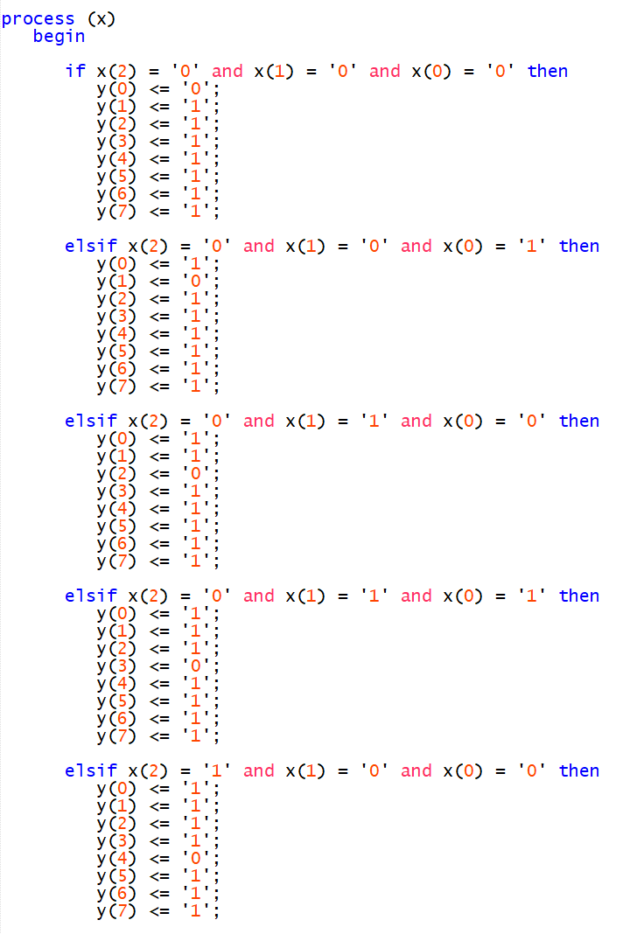

Figure 9, part 2 VHDL code snippet

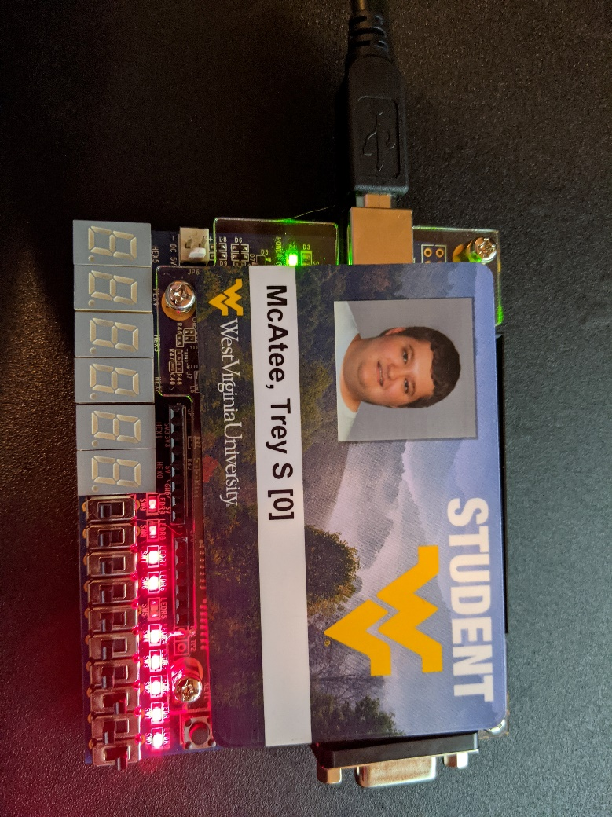

Figure 10, part 2 board results in(101) out(11011111)



Figure 11, part 2 board results in(011) out(11110111)

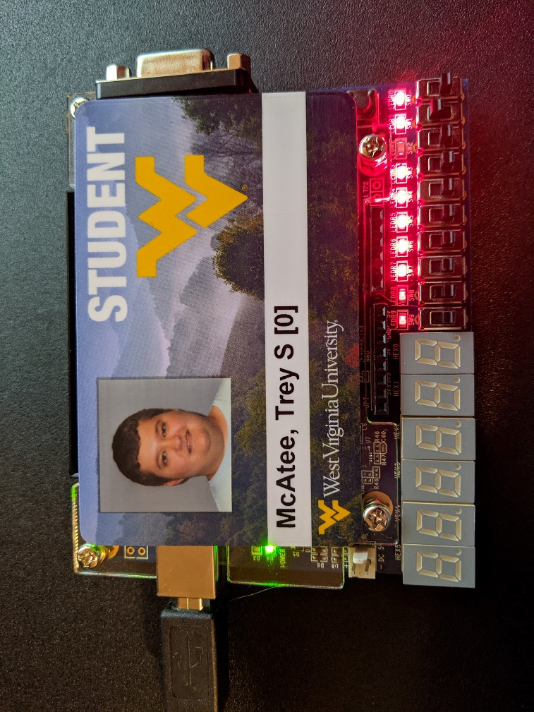

Figure 12, part 2 board results in(010) out(11111011)

**Part 3:**

**Experiment**

The experiment for part 3 was create a 4 to one multiplexer. It will have two switches that decide which input is outputted. We are given a truth table already filled out to represent what our results should look like, and are expected to come up with a block diagram, VHDL code, and display the results on the board.

**Results**

I started this part by drawing out the block diagram, and then went to code the structure in VHDL. After coding the VHDL behavior based on the truth table, I went to display the results on the board. Again, I am providing 3 photos instead of showing every scenario for the sake of brevity.

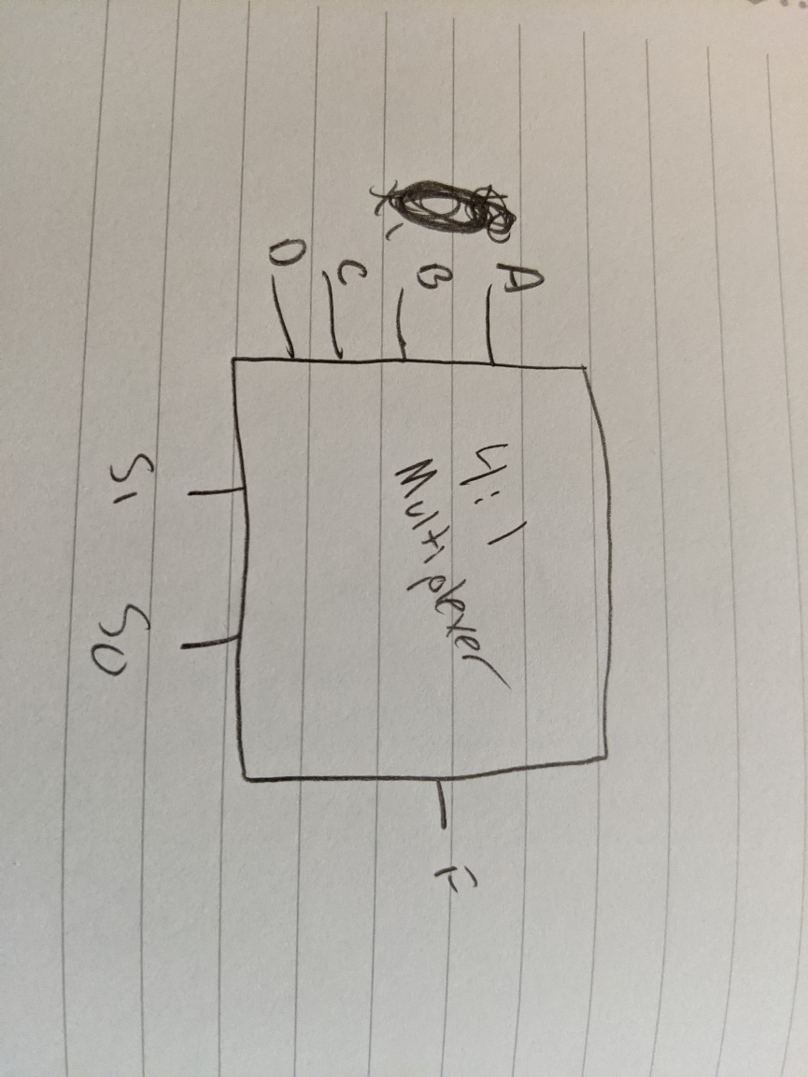

Figure 13, part 3 block diagram

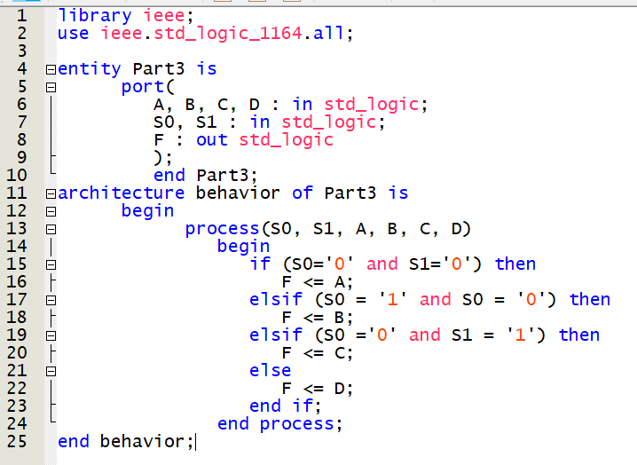

Figure 14, part 3 VHDL code



Figure 15, part 3 board results in(0010 10) out(0)



Figure 16, part 3 board results in(1001 11) out(1)

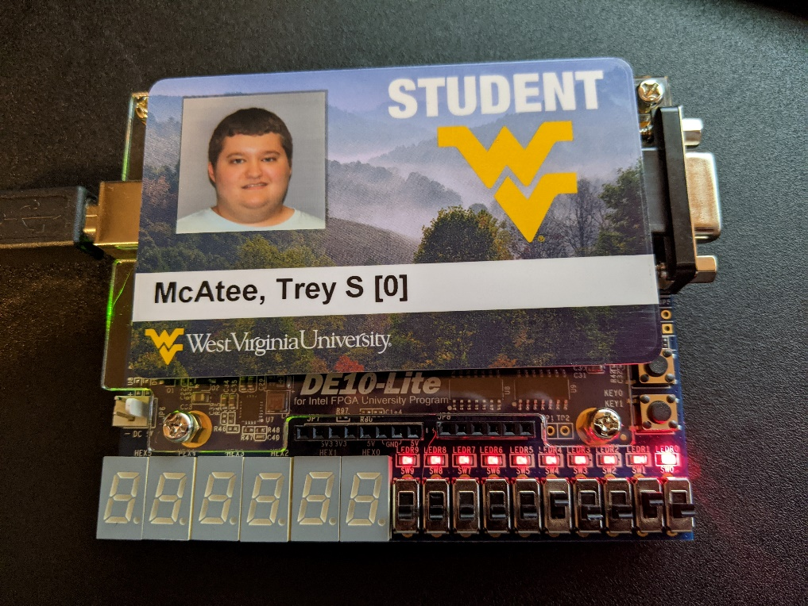

Figure 17, part 3 board results in(0100 10) out(1)

**Part 4:**

**Experiment**

The experiment for part 4 was import the code from part 3 and use it to accomplish a multiplexer circuit.

**Results**

For this part, I took some time to properly figure out the code for using another set of code, and then I just went ahead and simulated the results on the waveform simulator once my code compiled correctly. I recorded some of the results of my adder in the below table, and then confirmed them myself by writing them out by hand. Photos of my VHDL code, the table, and the waveform simulation results are posted below.

|  |  |  |  |  |  |
| --- | --- | --- | --- | --- | --- |
| S(1) | S(0) | X(1) | X(0) | F1(expr) | F1(val) |
| 0 | 0 | 0 | 0 | X(0) & x(1) | 0 |
| 0 | 0 | 0 | 1 | X(0) & x(1) | 0 |
| 0 | 0 | 1 | 0 | X(0) & x(1) | 0 |
| 0 | 0 | 1 | 1 | X(0) & x(1) | 1 |
| 0 | 1 | 0 | 0 | X(0) or x(1) | 0 |
| 0 | 1 | 0 | 1 | X(0) or x(1) | 0 |
| 0 | 1 | 1 | 0 | X(0) or x(1) | 1 |
| 0 | 1 | 1 | 1 | X(0) or x(1) | 1 |
| 1 | 0 | 0 | 0 | X(0) | 0 |
| 1 | 0 | 0 | 1 | X(0) | 1 |
| 1 | 0 | 1 | 0 | X(0) | 0 |
| 1 | 0 | 1 | 1 | X(0) | 1 |
| 1 | 1 | 0 | 0 | X(1) | 0 |
| 1 | 1 | 0 | 1 | X(1) | 0 |
| 1 | 1 | 1 | 0 | X(1) | 1 |
| 1 | 1 | 1 | 1 | X(1) | 1 |

Figure 18, part 4 truth table

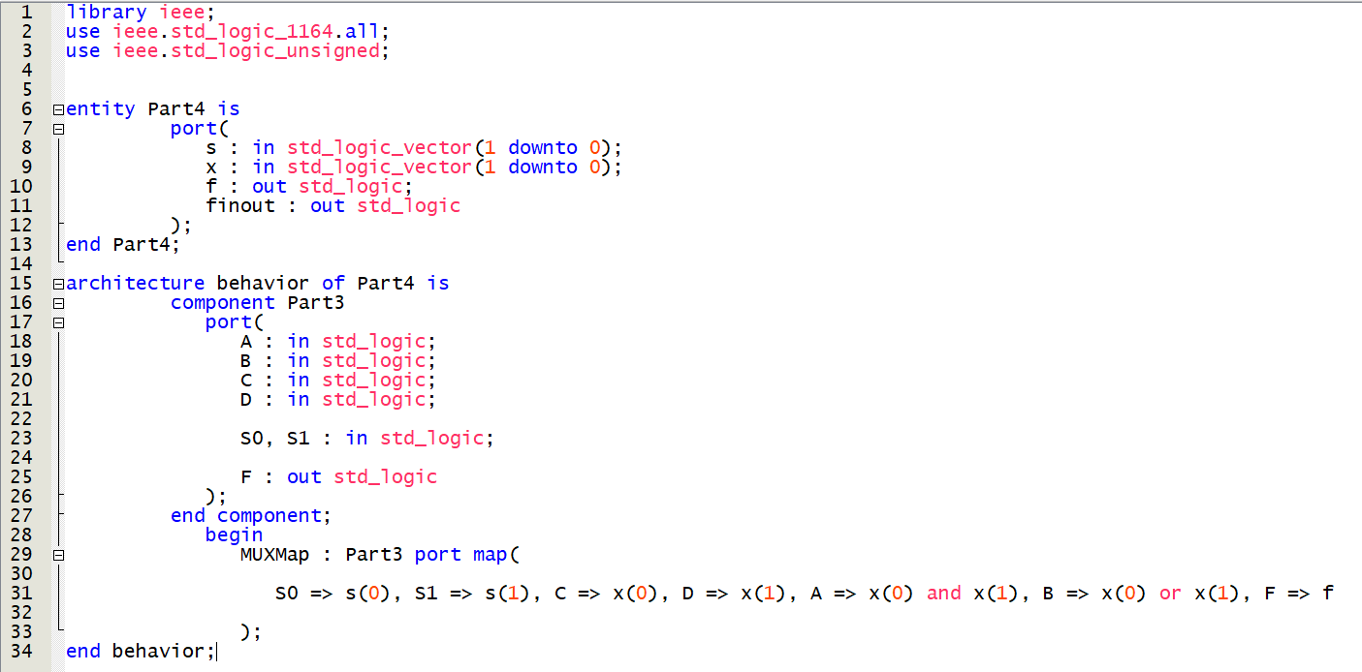

Figure 19, part 4 VHDL code

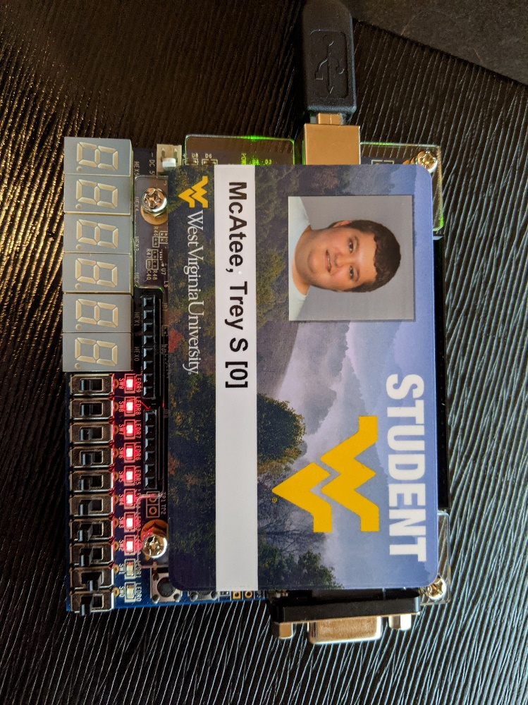

Figure 20, part 4 board results in(1000) out(0)

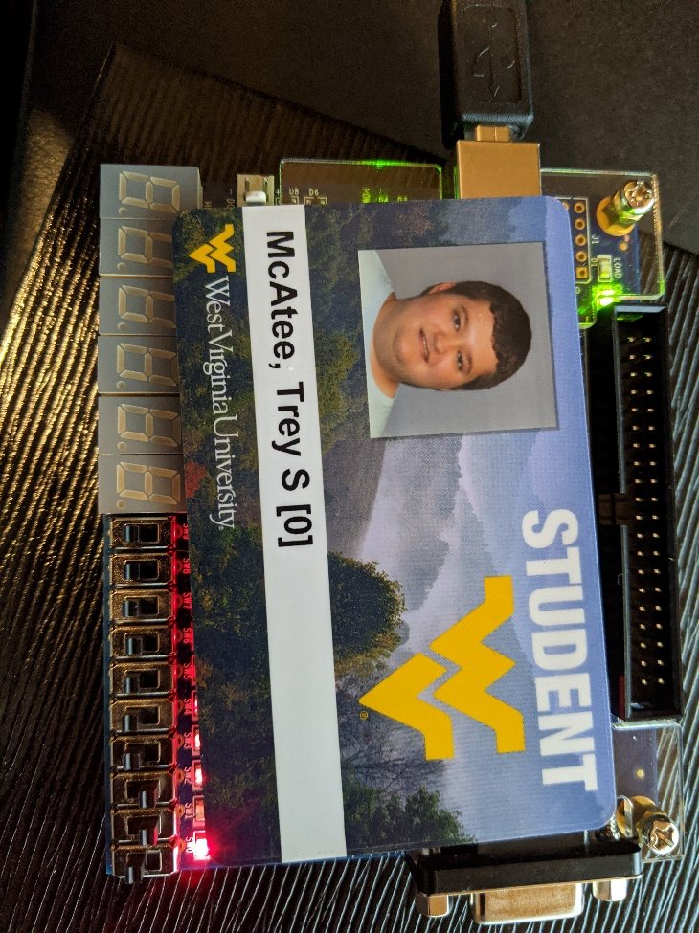

Figure 21, part 4 board results in(1001) out(1)

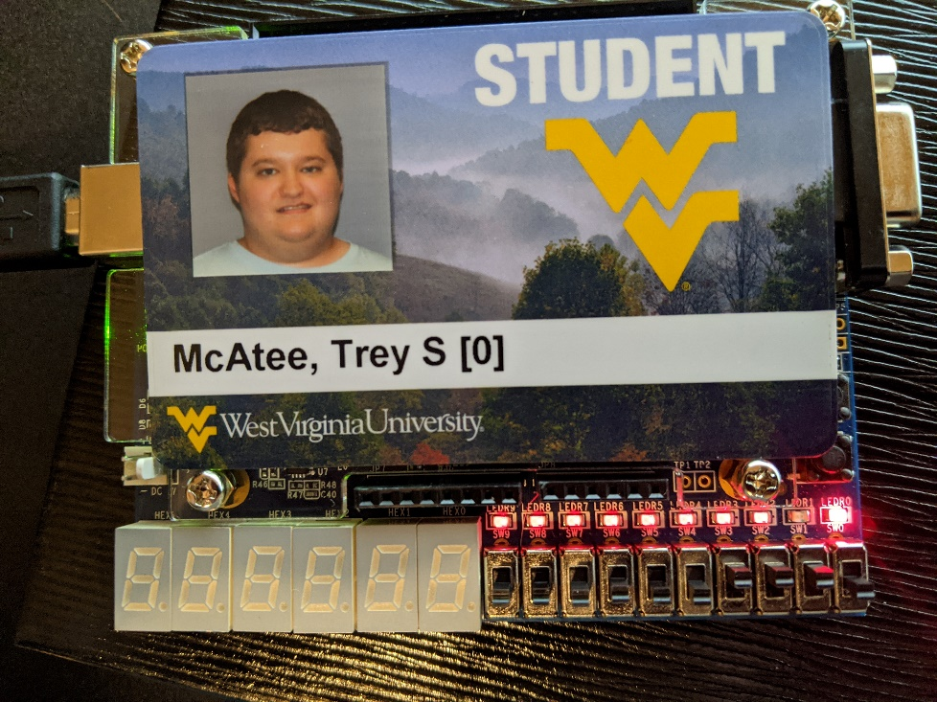

Figure 22, part 4 board results in(1011) out(1)

**Conclusion:**

What I learned in this lab was how to perform even more complex operations in VHDL. I was able to grasp the if/elsif/else structure quite quickly, perhaps due to general prior programming experience, perhaps due to experience with python in particular. Outside of that, however, I was able to successfully create multiplexer along with a priority encoder and decoder. My recommendation for this lab would be to go more in depth with the explanation of part 4 at least, as I was confused on how to proceed for a little while.

POST LAB QUESTIONS:

1. The operation is 2^4 -1, so it is 16-1 which comes to 15 inputs.
2. The operation is 2^4, so it is 16 inputs.

PRE-LAB 6 QUESTIONS:

1. A flip flop is a type of circuit that flips a boolean from false to true under certain conditions and then back to false under a new condition. The types are D-Flip Flop, T-Flip Flop, SR-Flip Flop, and a JK-Flip Flop.
2. It captures the value of the d input and makes it into the q output. It is called the “data” or “delay” flip flop.

**Sequential Logic Design Part II**

Trey McAtee

CPE 272 Lab 7

11/8/2020

No Partners

**Introduction**

The seventh lab of CPE 272 is meant to give students a more advanced level of understanding of VHDL code and how it can be implemented to represent different scenarios, focusing on flip flop circuits and the boards internal clock in this lab.

**Part 1:**

**Experiment**

The experiment for part 1 was to program a D- Flip Flop in VHDL and correctly visualize the results on the board. To accomplish this task, we’ve been introduced to a clock implementation in VHDL, where the clock cycles between 1 and 0.

**Results**

I programmed the VHDL code according to the specifications in the lab handout and verified the results with what a D Flip-Flop is supposed to do. I also performed the 4 operations required after programming the board and took pictures of the 3 that were necessary. As for the fourth question there, the output does not change because of the clock cycle. I also used the state table listed out in the lab handout. In other words, the results from the board are such that when I turn on D, the output is logic low. When I then turn on the clock input, the output is logic high. I can then manipulate the D input however I like and the output will not change unless I also turn the clock to logic low. Also, the clock input alone will not make the output logic high. For this to occur, D must be logic high before the clock input is turned on.

|  |  |
| --- | --- |
| Input | Output |
| 0 | 0 |
| 1 | 1 |

Figure 1, part 1 state table

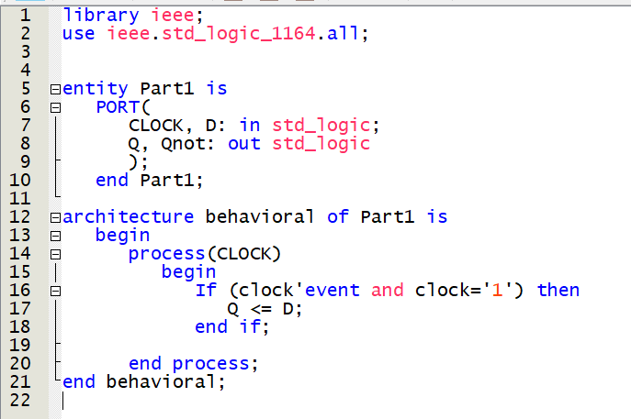

Figure 2, part 1 VHDL Code

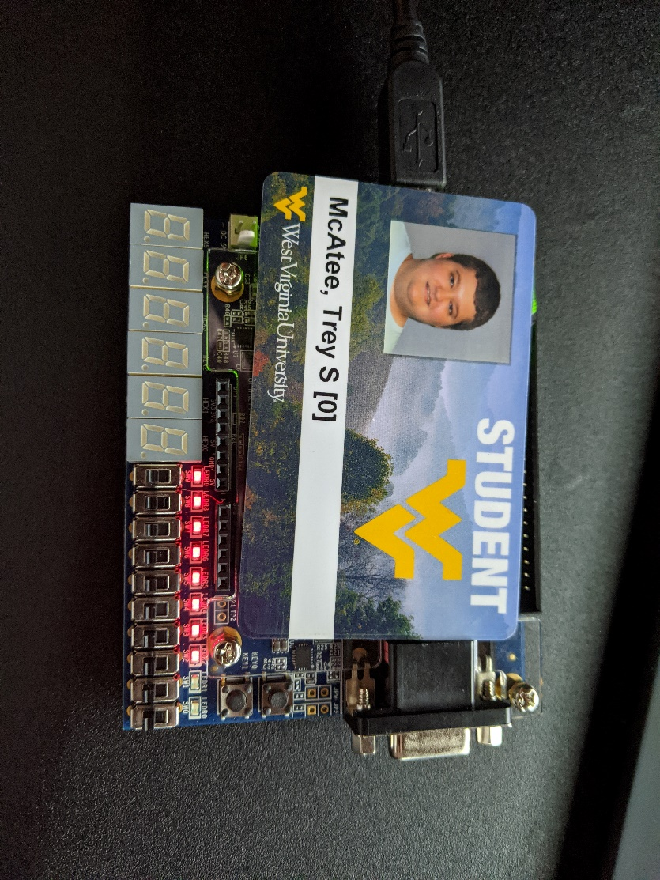

Figure 3, part 1 board results in (00) out (00)

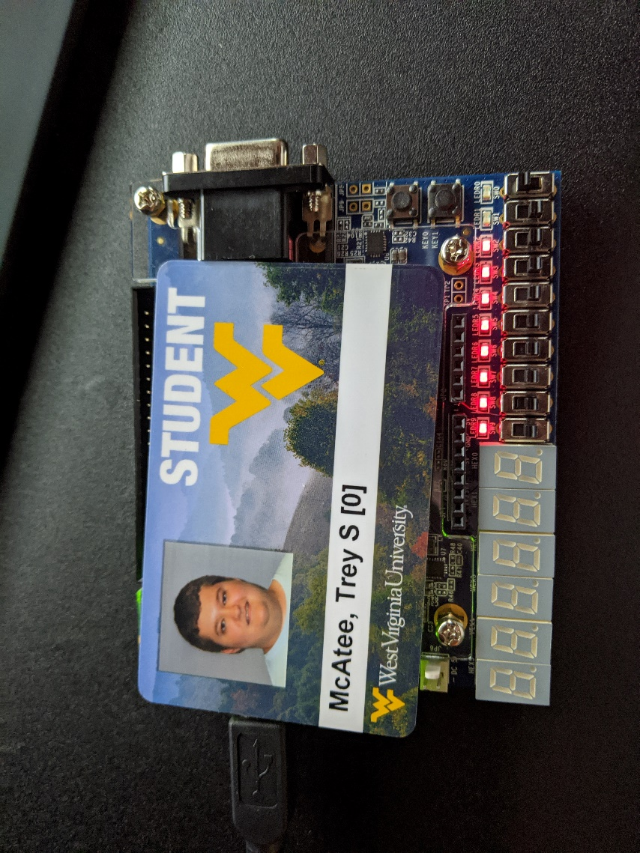

Figure 4, part 1 board results in (01) out (00)

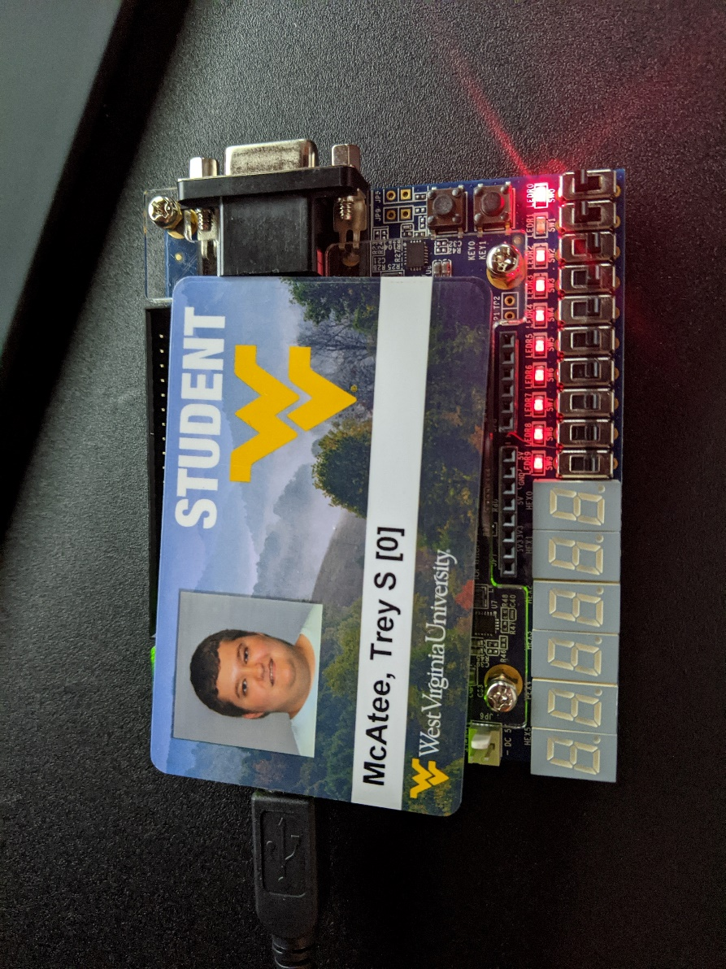

Figure 5, part 1 board results in (11) out (01)

**Part 2:**

**Experiment**

The experiment for part 2 was create a clock divider where we can slow down the clock to actually see what is happening with the time interval of the board. There is code provided to be used in the lab handout for this purpose, so all there really is to do is program the board correctly and interpret the results.

**Results**

I started by taking the VHDL code from the handout and trying to make sure I understood what it did, and why it made the statements it made. Next, I went to program the board and assigned the input clock_in to PIN_P11, and the output clock_out to LED PIN_A8. The results on the board are that every second the LED light will toggle, with no user input required. What the VHDL code effectively does is take an integer x and increment it along with the clock cycle to 50000000 before resetting it to 0 and toggling the LED to the other configuration of either logic high or logic low.

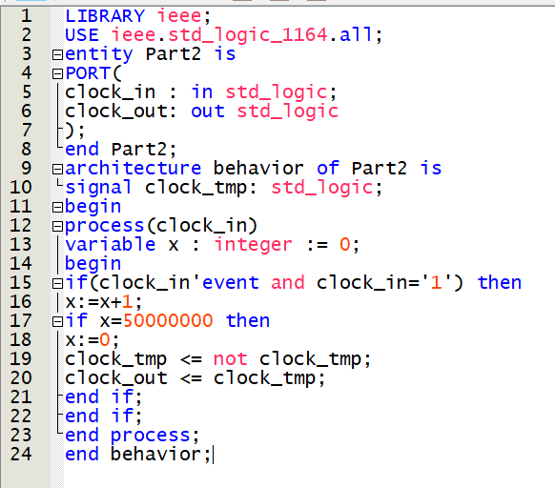

Figure 6, part 2 VHDL code

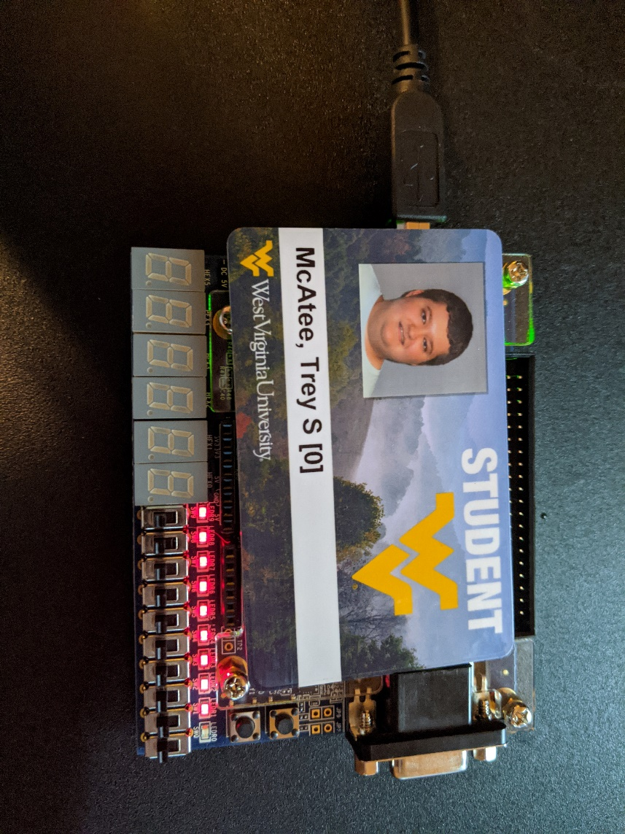

Figure 7, part 2 board results

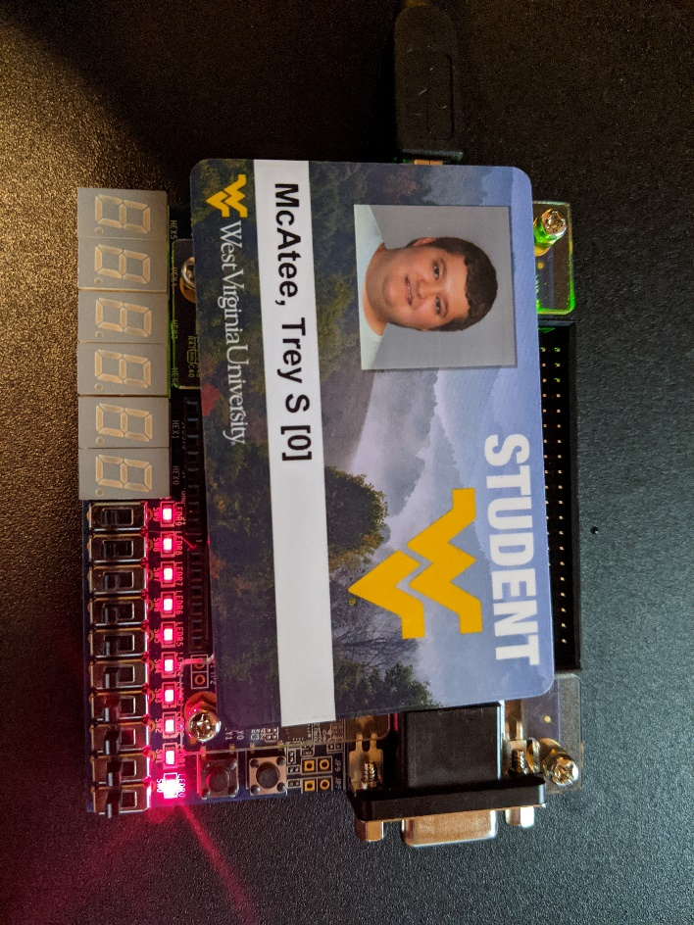

Figure 8, part 2 board results

**Part 3:**

**Experiment**

The experiment for part 3 was to effectively combine parts 1 and 2 from this lab. We need to create a slow version of the D Flip-Flop. We must use two port maps to help accomplish this goal.

**Results**

I started this part by moving files over to my new part3 folder, and then began to code. I essentially just made similar code to that of parts one and two, and then in the port maps I matched up my new variables for Part3 to the variables they should be paired with in my port maps. When testing the board, D was required to be logic high for the LED to be on, which represents my results from part 1 successfully.

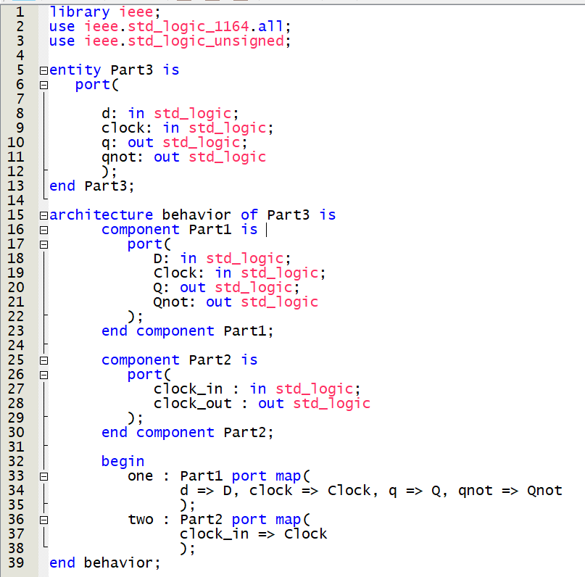

Figure 9, part 3 VHDL code



Figure 10, part 3 board results in(0) out(00)

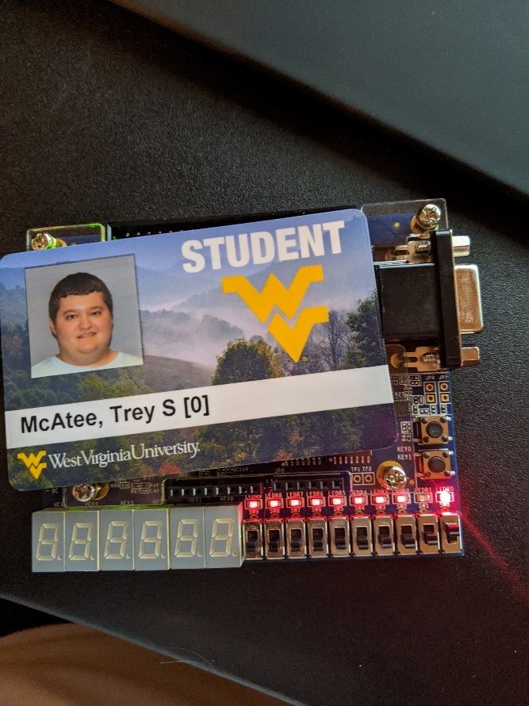

Figure 11, part 3 board results in(1) out(1)

**Conclusion:**

What I learned in this lab was how to perform even more complex operations in VHDL. Using two port maps in Part 3 messed me up a bit, and I had to take a bit more time on that than I originally expected too. Outside of that, however, I was able to successfully create a slowed down D Flip-Flop along with the two individual parts that combine to make it. My recommendation for this lab would be to go more in depth with the explanation of part 4 at least, as I was extremely confused and had an incredible amount of trouble with this part.

POST LAB QUESTION:

1. Minterms: A’B’ + D’

PRE-LAB 8 QUESTION:

1. The difference is that in the Mealy model, the output is a function of both the present state and the input while in the Moore model, the output is a function of only the present state.

**Sequential Logic Design Part II**

Trey McAtee

CPE 272 Lab 8

11/8/2020

No Partners

**Introduction**

In the eighth lab of CPE 272 students will need understand boolean expressions, truth tables, and k-maps, and they can use such concepts to program efficient logic arrays that make decision making simple. This is the purpose of the eighth lab, as Mealy and Moore State Machines are meant to boost circuit efficiency while simplifying the decision-making process through state design.

**Part 1:**

**Experiment**

Part 1 of the lab was split into two parts, Task 1 and Task 2. They each had a set of direct questions to answer and had a diagram to fill out. For task 1, I had to distinguish whether Figure 1 represented a Mealy or Moore model. Then, I had to analyze the model to determine the output sequence and final state of the machine when the machine’s input was “010010”. Afterwards, I worked with a run-time simulation diagram where I had to fill out the STATE and OUTPUT sections of the diagram (Figure 2).

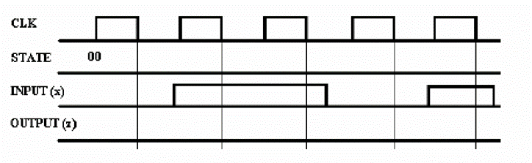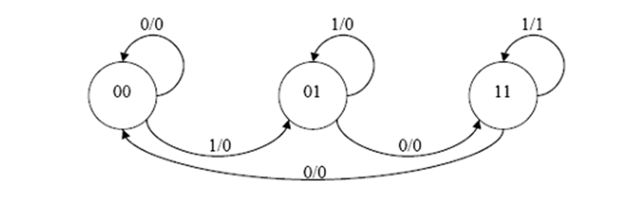

Figure 1: Mealy Diagram

Figure 2: Time Diagram

For task 2, I had to analyze a sequential circuit diagram (Figure 3) and answer more questions. I needed to determine the type of flip-flop which was used in the circuit, and then determine how many states the circuit used. Afterwards, I derived Boolean expressions for the circuit’s output ‘Z’, and node ‘T’. Once completed, I used the diagram and Boolean expressions to derive a state transition table, which includes the present state, present flip-flop inputs, next state, and outputs of the function.

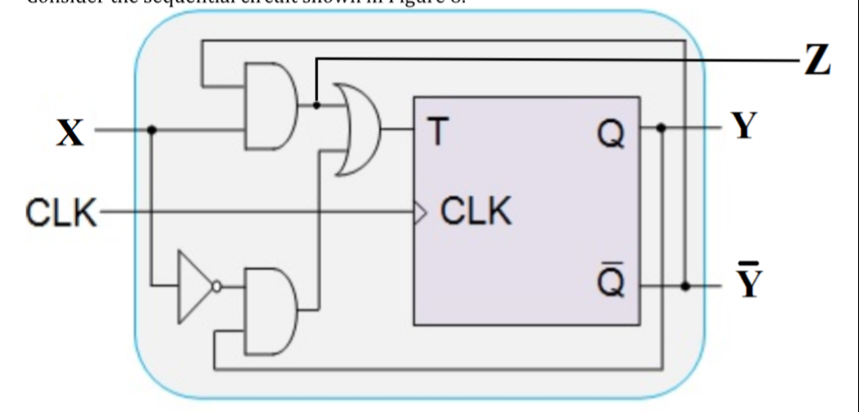 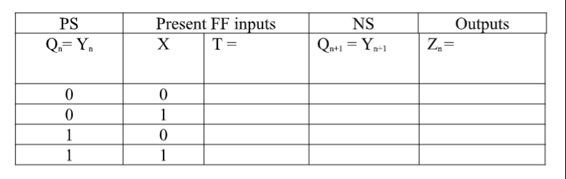

Figure 4: Transition Table

Figure 3: Logic Diagram

**Results**

Task 1 Questions:

1. I determined that figure 1 represented a Mealy Model, as it references post present and future states as inputs.
2. The output sequence of that circuit would be 000000 and remain in state 11.
3. Figure 5:

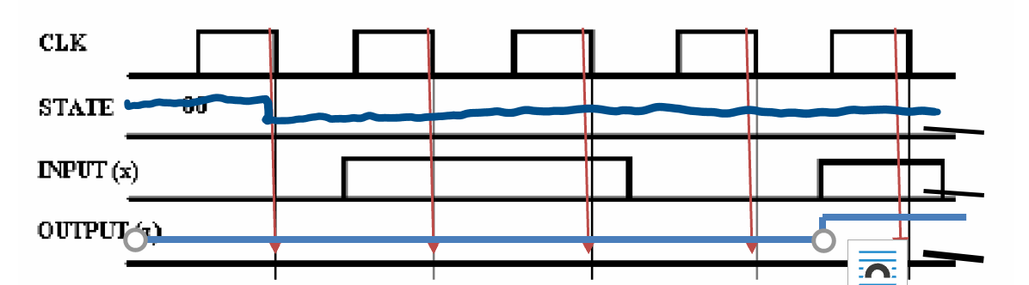

Figure 5: Time Diagram

Task 2 Questions:

1. It’s a T flip-flop.
2. 3 states
3. T = Qx + Qn’X’
4. Z = Qn’x’ + Qnx

Figure 6: Transition chart

**Part 2 Experiment 1, 2, and 3:**

**Experiment**

In part 2 experiment 1 of the lab, we must use the binary state table supplied to realize a state table using a D Flip Flop. We should fill out a k-map, a truth table, and then two more k-maps to help accomplish this. In experiment 2, you must code a VHDL file to represent this and create a Mealy diagram. In experiment 3, we rewrite the code and redo the diagrams to conform to a design where we care about the don’t cares.

**Results**

I completed experiment 1 by simply filling out the charts in the order they were required, and then went to code the VHDL file based on the results of the charts created and code from lab 7. The results are posted below in a picture of my notebook where I drew them out (Figure 7). For experiment 2, I have posted a picture of the VHDL code (Figure 8) and a picture of the waveform simulator results (Figure 9). I also rewrote the diagrams and updated the VHDL code (Figure 10) to conform to experiment 3, listed in pictures (Figure 12) below. I also made a Mealy diagram for experiment 3(Figure 13).

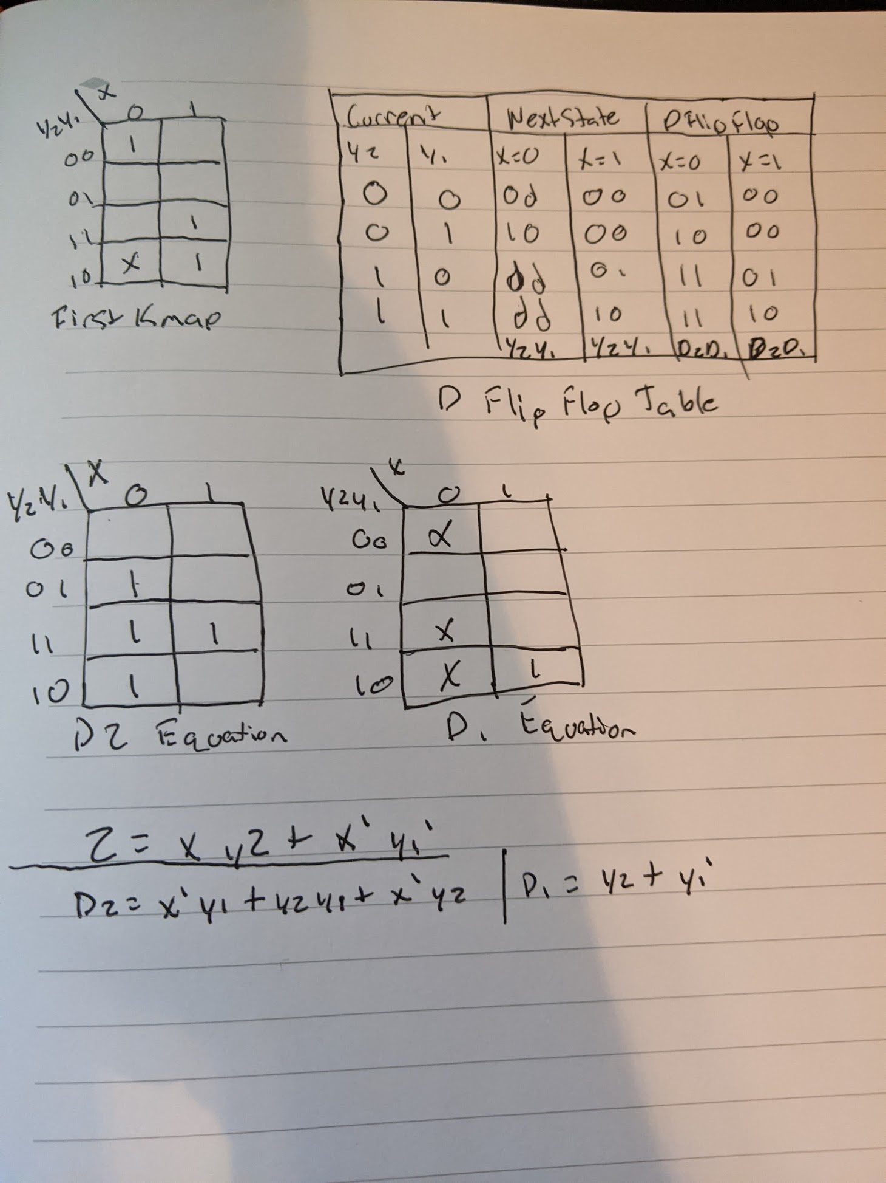

Figure 7, Kmaps/Truth Table/Equations

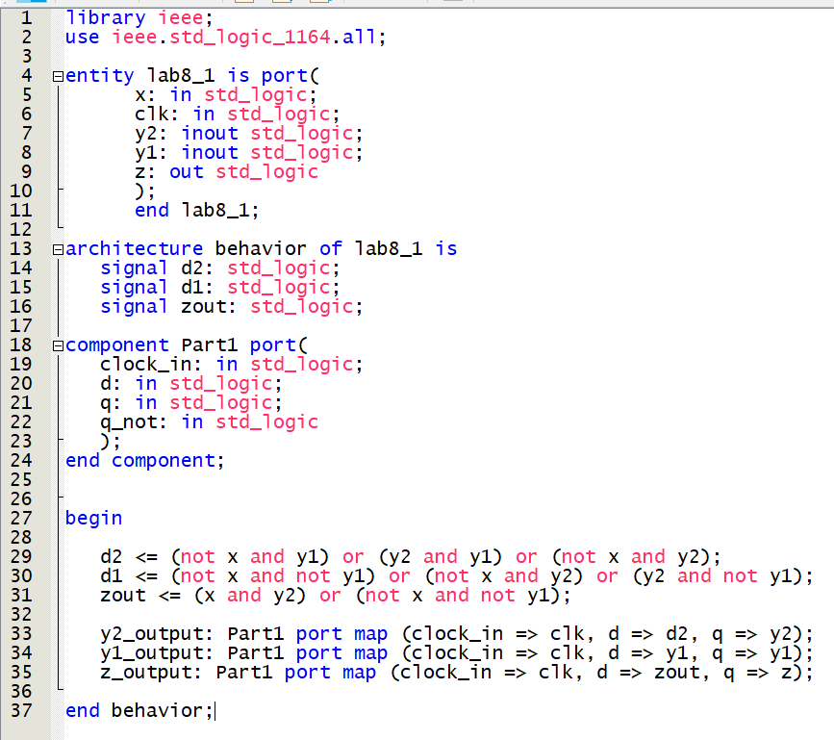

Figure 8, Experiment 2 VHDL Code

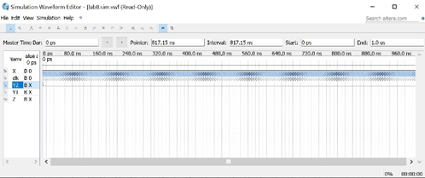

Figure 9, Experiment 2 Waveform Sim

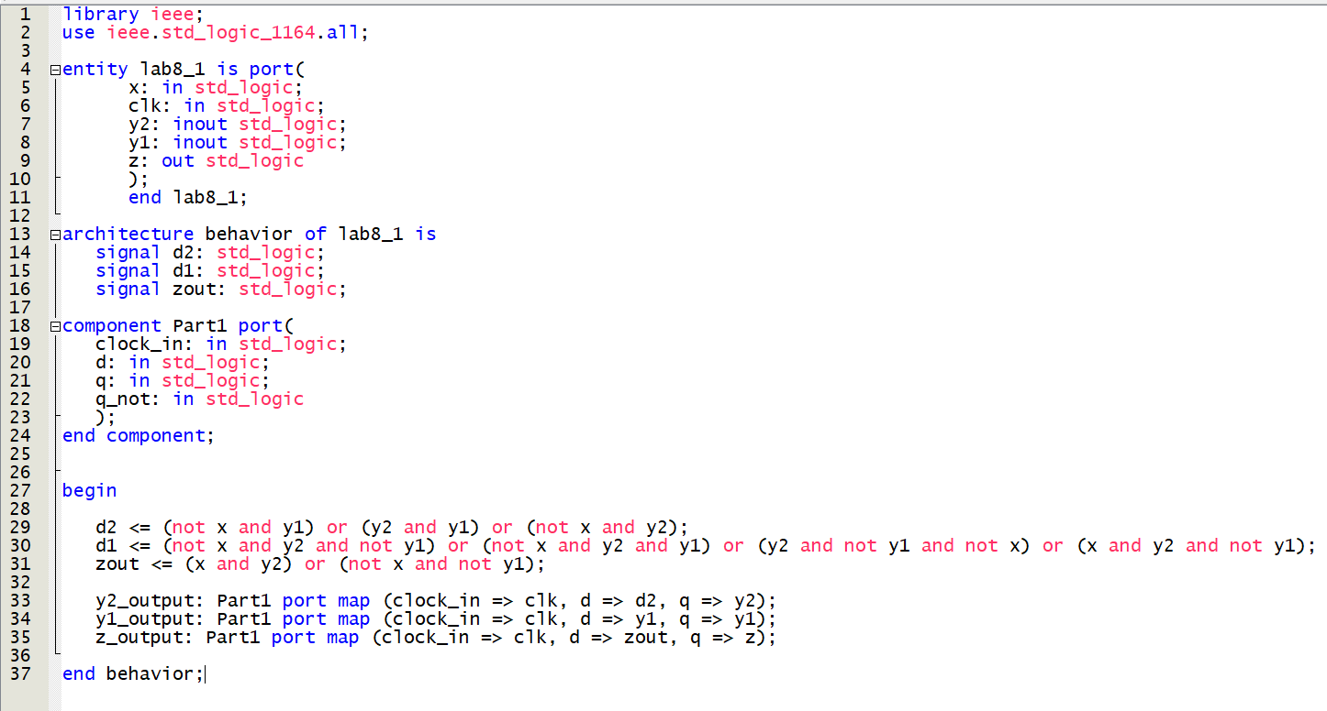

Figure 10, Experiment 3 VHDL Code

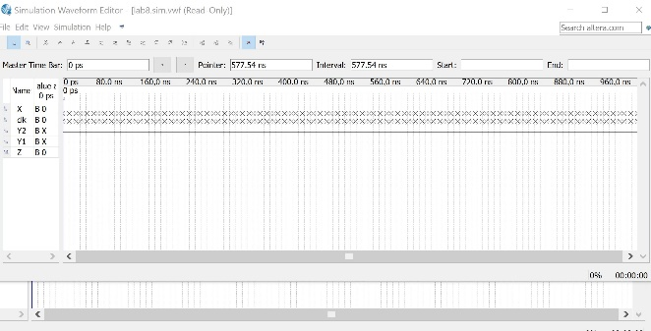

Figure 11, Experiment 3 Waveform Sim

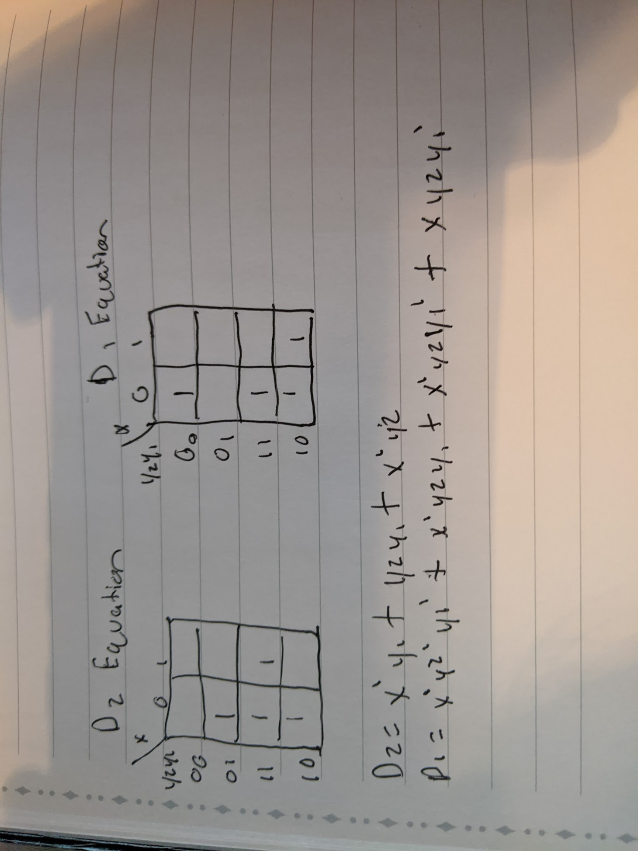

Figure 12, Experiment 3 Kmaps

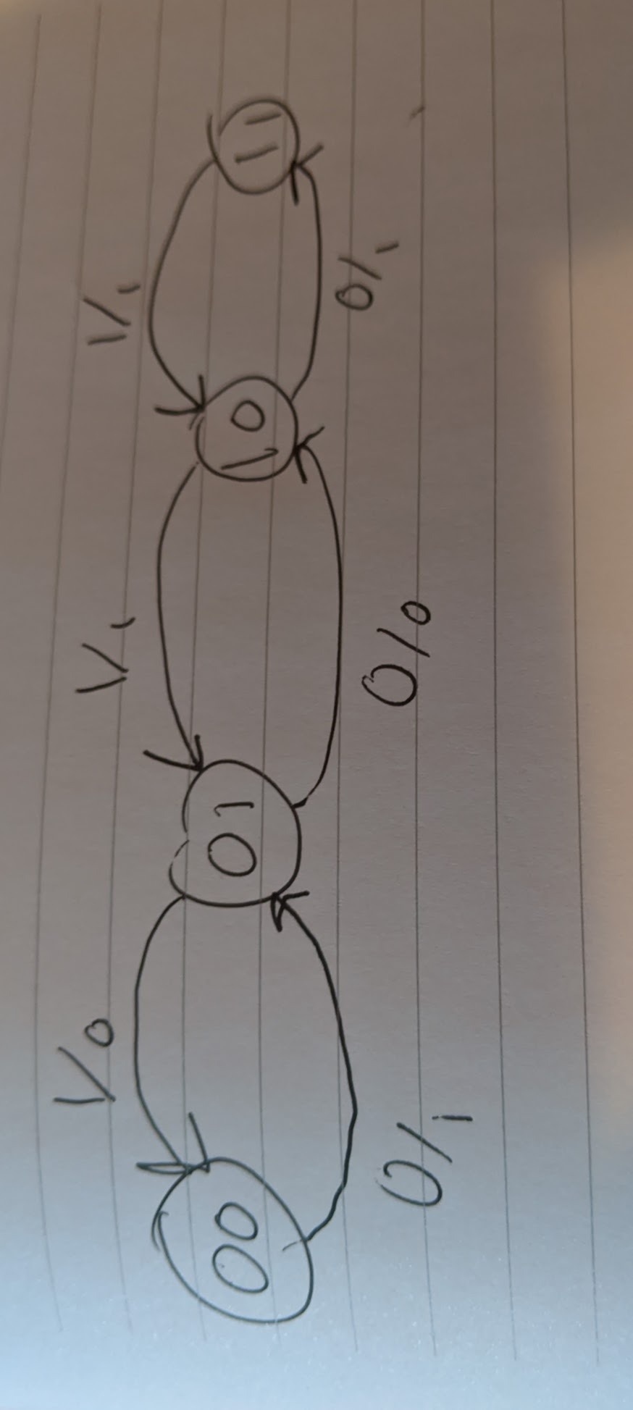

Figure 13, Experiment 3 Mealy Diagram

**Conclusion**

In this lab, what I learned was the importance of modular design. Modular based circuit design is proven to be effective to implement in the sense that you can create unique and complex circuits with ease. What I would change about this lab is the size of the circuit we are building. If it was larger, it would do more to represent the complexity of Mealy and Moore state machines.

POST LAB 8 Questions:

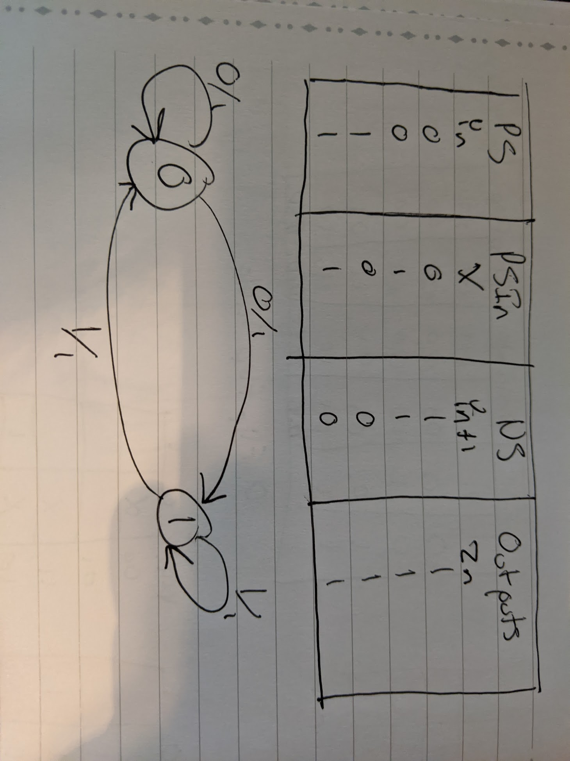

Figure 14, Post lab question answer

PRE LAB 9 Questions:

1. An ALU is an Arithmetic Logic Unit, which means it’s a digital circuit that performs all logic expressions, arithmetic, as well as comparison operations.
2. An enumeration type is a special data type that enables for a variable to be a set of predefined constants.
3. RAM is Random access memory, while ROM is read only memory.

**Sequential Logic Design Using Behavioral Modeling & Memories and Arithmetic Logic Units**

Trey McAtee

CPE 272 Lab 9

11/8/2020

No Partners

**Introduction**

CPE 272’s lab 9 aims to reveal how state machines and FSM’s can boost circuit efficiency while simplifying the decision-making process through the use of modular states in memory. This experiment shows the significance and relevance of memories in digital systems.

**Part 1:**

**Experiment**

Part 1 required a constructed Mealy Finite State Machine in VHDL code. To do this, I used a sample Mealy Machine diagram from the lab handout to determine the flow of the circuit and distinguish the correct inputs for each state. Once completed, I used the waveform simulator for testing. Afterwards, I worked on the output table for the Mealy FSM.

**Results**

To accomplish the experiment for part 1, I started by looking over the sample Mealy FSM code from the lab handout and the Mealy FSM diagram given to make sure I properly understood it. Then, I went to implement it in VHDL. Below is a screenshot of my implementation for it, along with the Mealy diagram supplied and the filled out output table. I have also attached the waveform simulator results.

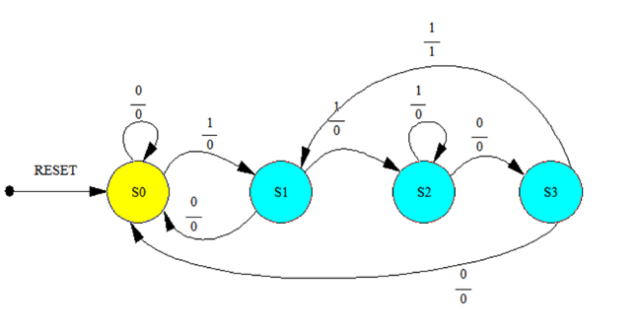



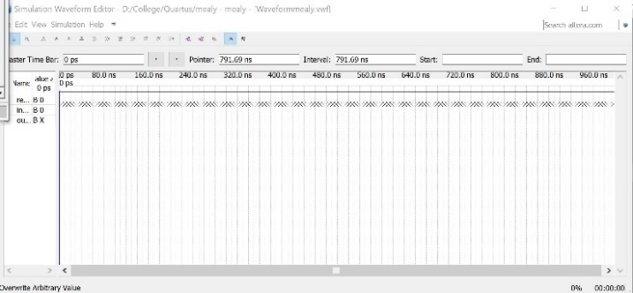 Figure 2, Output Table

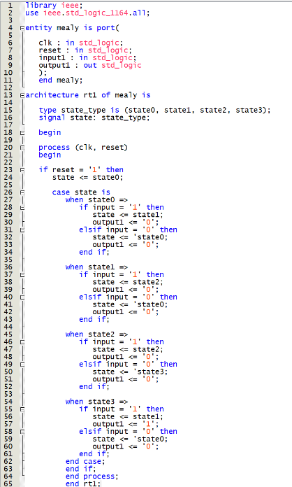Figure 1, Mealy FSM Diagram

Figure 3, Waveform Sim Results

Figure 4, Mealy VHDL code

**Part 2:**

**Experiment**

Part 2 required a constructed ALU. An ALU is an Arithmetic logic unit, and there were some diagrams provided to assist students in understanding what exactly to do. There was also a table showing different operation codes for the ALU. Two new imports are to used for the ALU VHDL implementation as well, the arith and unsigned libraries. Finally, there would be an ALU output table to fill out.

**Results**

I started part 2 by familiarizing myself with the diagram and tables provided. Once I felt confident, I filled out the output table and then started to implement it in VHDL. My implementation as well as the filled out table and picture of the board is listed below.

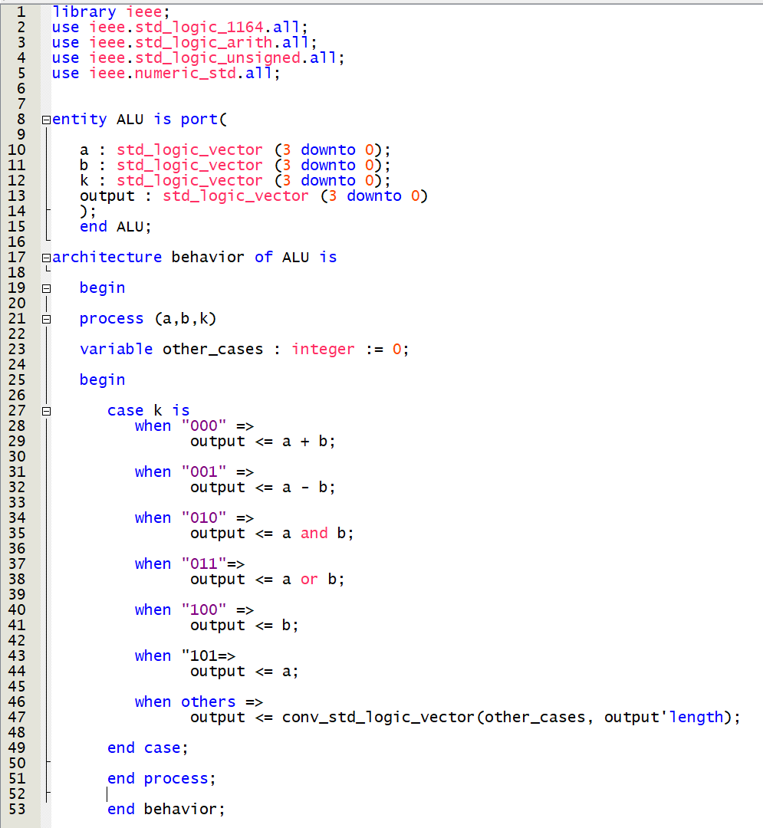



Figure 5, ALU VHDL Code Figure 6, Output table

Figure 7, board results

**Part 3 Experment 1 & 2:**

**Experiment**

Part 3 experiment 1 of the lab was about creating an 8 bit * 32 Memory ROM. A diagram of a ROM device was supplied in the lab handout to assist students in implementing the ROM. Students should explain the results of the code as well. Part 3 experiment 2 of the lab was about implementing RAM. Another diagram was supplied and students should explain the output again.

**Results**

I started part 3 experiment 1 by looking over the diagrams and quickly getting started to implement it the VHDL code. My code is posted in a screenshot below as a code snippet. The only thing not included is the full line 27. I was unable to actually get this code to work correctly. I kept receiving the same errors over and over again, no matter what I attempted to change. Basically, quartus would tell me that it could not find my ports. Specifically, my read_addr ports. I had effectively the same process to try and implement the RAM code, which turned out somewhat similar in both implementation and results. There were more errors with being unable to find ports in my RAM implementation as well.

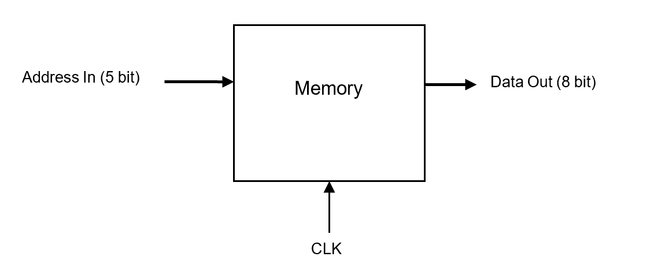

Figure 8, 8 bit * 32 Memory Block Diagram

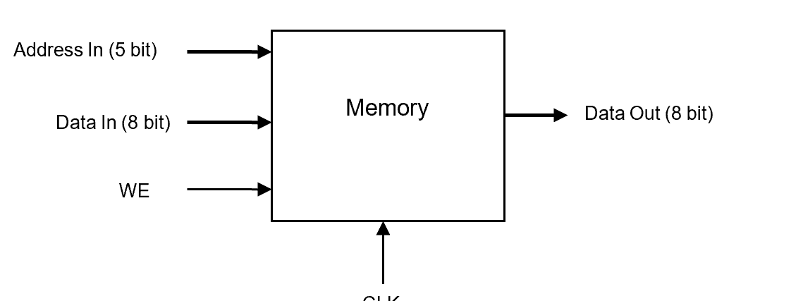

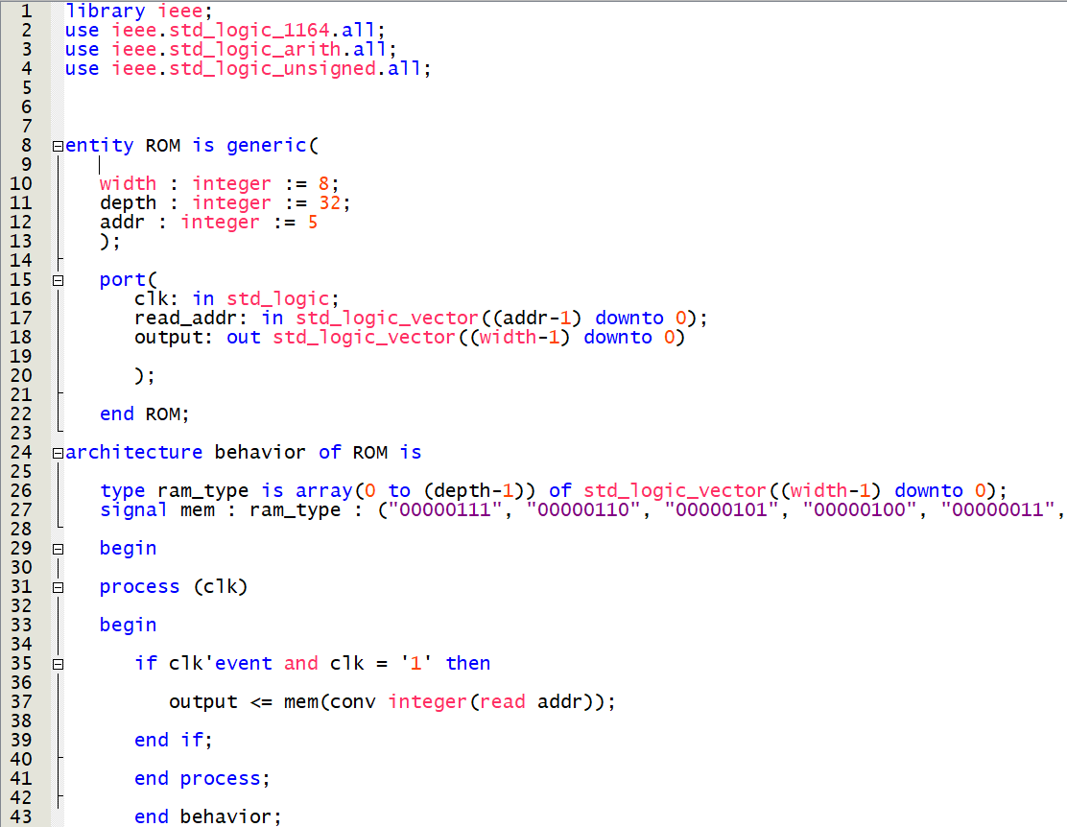 Figure 9, RAM Diagram

Figure 10, ROM VHDL code snippet (rightmost part of line 27 cut off)

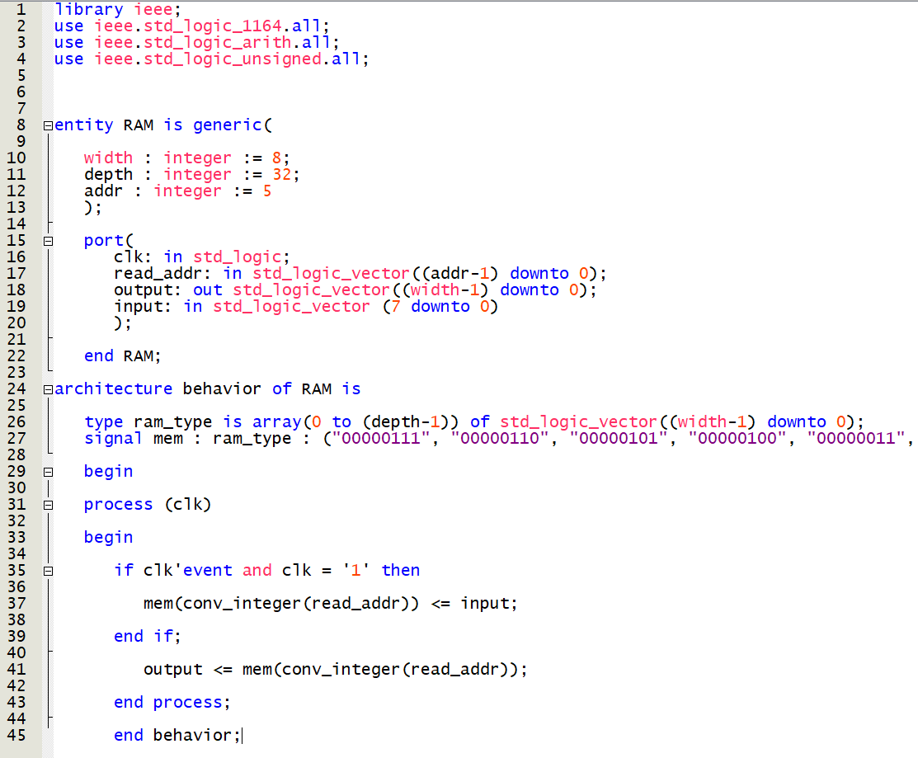

Figure 11, RAM VHDL code snippet (rightmost part of line 27 cut off)

**Conclusion**

This lab continues to reinforce the importance of modular design by showcasing that modular-based circuit design is easier on the eyes and makes more complicated circuits easier to implement. Memories are also essential for logic designs to work, as the space ROM or RAM designates from data writing allows logic flow to be preserved in memory. As previously stated, I had numerous errors with correctly implementing my VHDL code, although I have traced through the logic in my code and I believe I should have the correct implementation, still. My assumption is that there was an issue of some sort with Quartus itself, maybe some corrupt file. I would try to improve this experiment by using circuits which have bigger memories and ALU’s, to help to engage the student with the true power of these designs.

PRE LAB 10 QUESTIONS

1. A plc is a programmable logic controller. It is used in situations that require high reliability, ease of programming and process fault diagnosis.
2. Ladder logic is a method to document the design and construction of relay racks as used in manufacturing and process control.

**Introduction to Programmable Logic Controllers & Ladder Logic Design**

Trey McAtee

CPE 272 Lab 10

12/7/2020

No Partners

**Introduction**

CPE 272’s lab 10 is about using PLCs and ladder logic design. Unfortunately, students are not present to actually experiment with the physical PLCs but the instructor has provided videos with proper output.

**Part 1:**

**Experiment**

In part one of the experiment, students are expected to analyze a PLC program (figure 1 & 2) and be able to explain what they are and what their purpose is.

**Results**

For task 1, I mainly used the reference manual linked at the very bottom of the lab handout for my information. It was extremely informative and helped me to understand what exactly it is that I was looking at. Components A, B, and D were determined to be NO contacts, which send charges throughout the PLC that are dependent on the input. Components C and D share a name, T1. This is because T1 represents the input for the timer (the actual timer being C, and D’s status being controlled by C). The timer also sends a signal out on a 5 second interval. Component E represents the actual output of the PLC, and component F simply represents the end of the PLC.

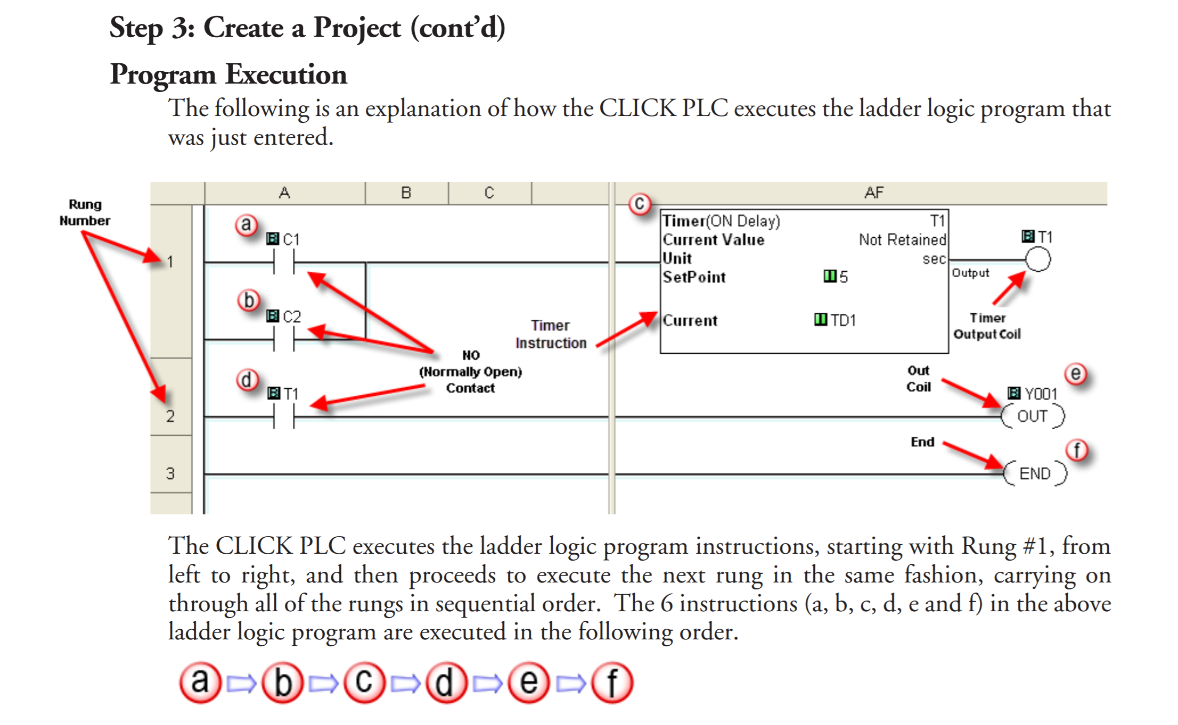

Figure 1, PLC program

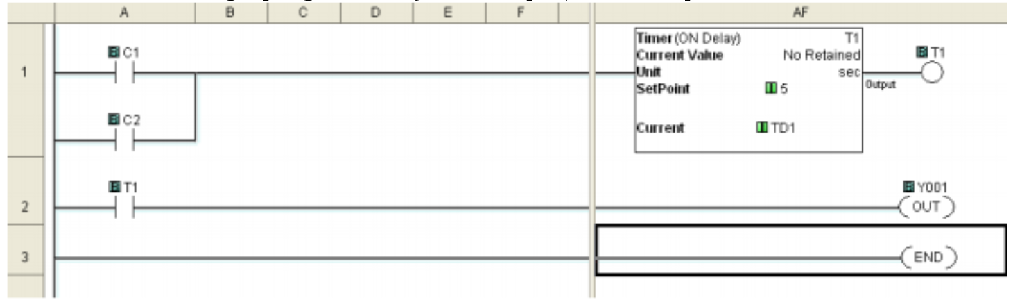

Figure 2, ladder logic program

**Part 2:**

**Experiment**

In the part two of the experiment, students had to create a PLC ON/OFF counter. The requirements for it were thus:

* Use two timers
* One NC contact
* One NO contact
* One output coil
* Use at most 4 rungs in implementation

**Results**

The first clock should turn on an LED signal for three seconds by charging contact T1. Next, the first timer should shut off for three seconds and the charge sent by the first clock will then charge the second contact, turning on the second clock for three seconds. This cycle will continue until the program is terminated by the end block. I am assuming the program was successful because I received 0 errors and 0 warnings from the compiler.

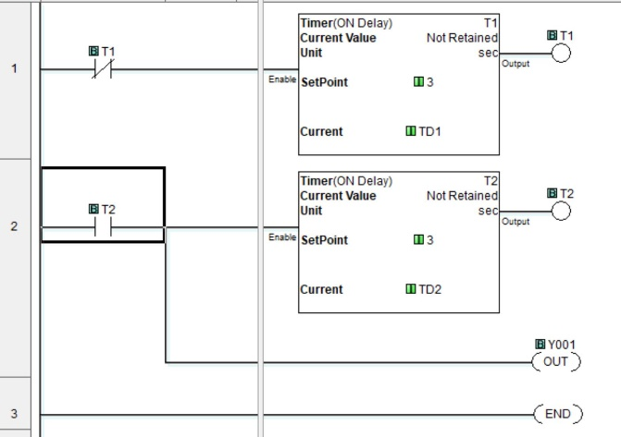

Figure 3, part 2 program

**Conclusion**

In this lab, I was able to learn the significance of software-reliant hardware. A PLC allows for circuitry to be implemented somewhat easily via software; implementing it physically would be much more difficult in contrast. This type of work can save an incredible amount of time and effort. To improve this experiment, I think you could add to the number of timers and contacts required to force students to work with a more complicated PLC. I believe it would enhance the general understanding for students of this topic.

POST LAB 10 QUESTIONS

1. Lab 3 was very enjoyable for me. I was extremely uncomfortable using the board until that lab, it was the first time I used the lab manual and I felt much more confident using the board after that. Creating the full subtractor in that lab was not the most difficult task, but I felt very accomplished after finishing.

**Lab Notes**

I would have some lab notes to post here (maybe 8 to 9 pictures worth) but I admittedly forgot to bring my notebook back to my family’s home with me from campus. Seeing as this section is apparently optional anyway, I just thought it was worth mentioning. I believe most of my notes were from lab 3 onward, covering things like simple VHDL syntax, practicing binary subtraction, taking individual notes from some lab reports if I saw something in particular I thought to be noteworthy, to practicing drawing FSM diagrams.